# INTRODUCTION

* 1. Overview

A brief description about your project

* 1. Purpose

The use of this project. What can be achieved using this.

1. **Problem Definition & Design Thinking**
   1. Empathy Map

Paste the empathy map screenshot

* 1. Ideation & Brainstorming Map

Paste the Ideation & brainstorming map screenshot

# RESULT

Final findings (Output) of the project along with screenshots.

# ADVANTAGES & DISADVANTAGES

List of advantages and disadvantages of the proposed solution

# APPLICATIONS

The areas where this solution can be applied

# CONCLUSION

Conclusion summarizing the entire work and findings.

# FUTURE SCOPE

Enhancements that can be made in the future.

# APPENDIX

A. Source Code

Attach the code for the solution built.

1. **INTRODUCTION:**

**1.1 OVERVIEW**

People who work frequently travel through flight will have better knowledge on best discount and right time to buy the ticket. For the business purpose many airline companies change prices according to the seasons or time duration. They will increase the price when people travel more. Estimating the highest prices of the airlines data for the route is collected with features such as Duration, Source, Destination, Arrival and Departure.

**1.2 PURPOSE**

Features are taken from chosen dataset and in the price where in the airline price ticket costs vary overtime. we have implemented flight price prediction for users by using KNN, decision tree and random forest algorithms. Random Forest shows the best accuracy of 80% for predicting the flight price. Also, we have done correlation tests and metrics for the statistical analysis.

**2. PROBLEM DEFINITION & DESIGN THINKING**

**2.1 EMPATHY MAP**

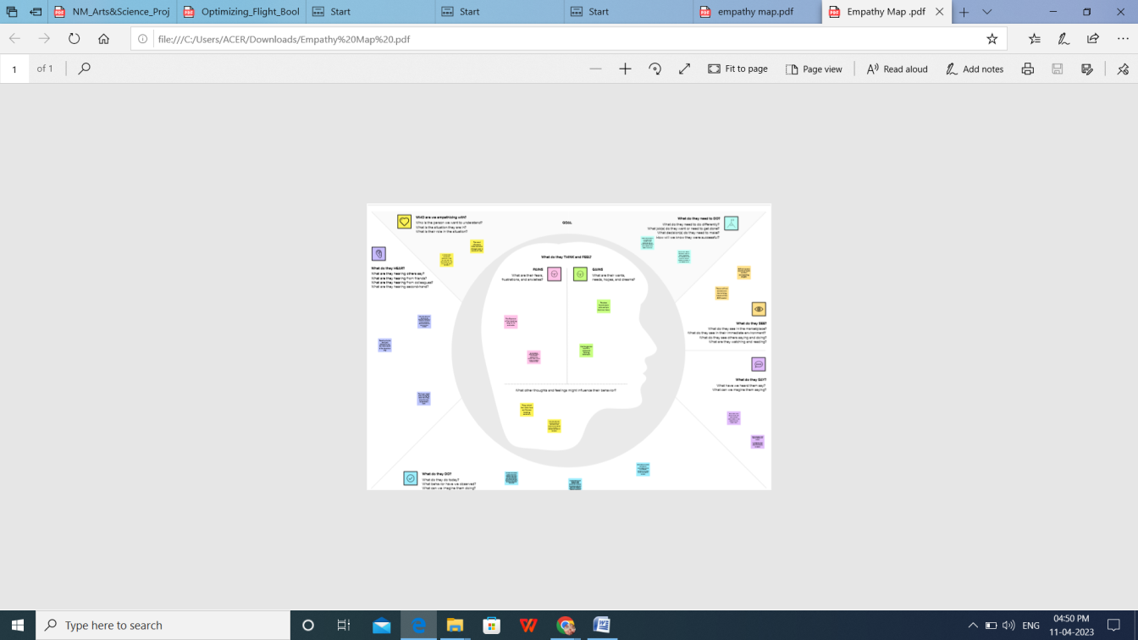

**2.2 IDEATION & BRAINSTORMING MAP**

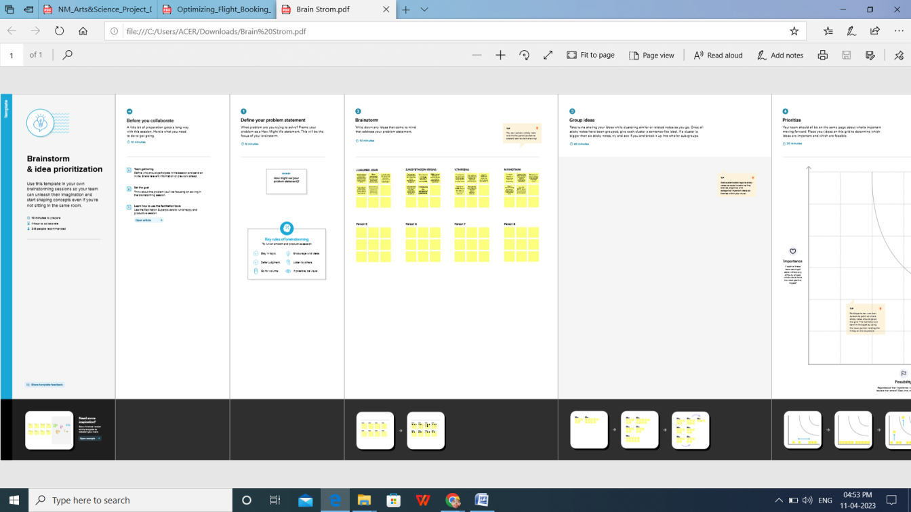

1. **RESULT:**

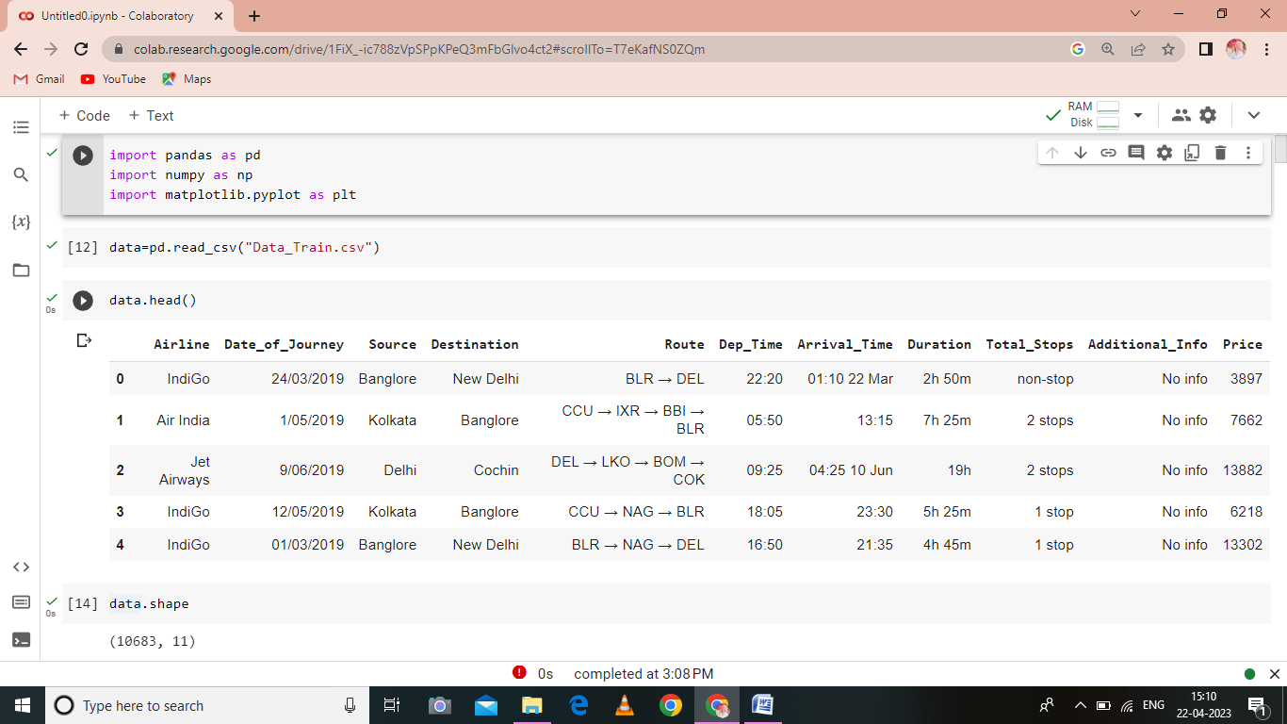

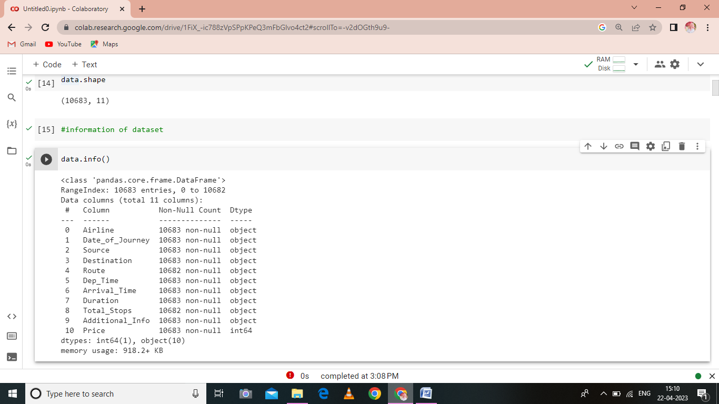

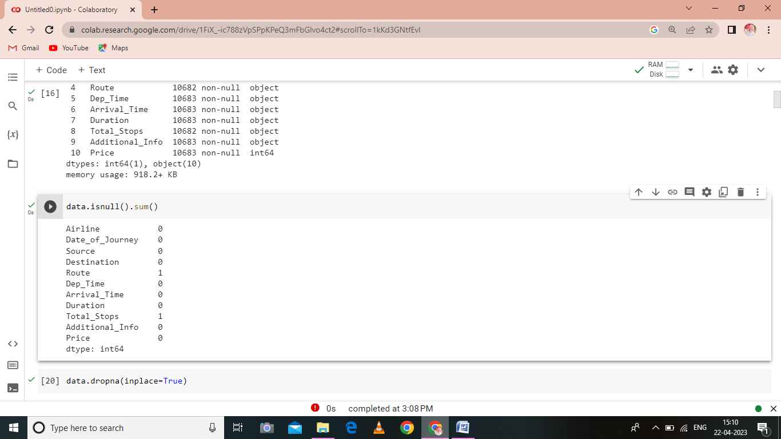

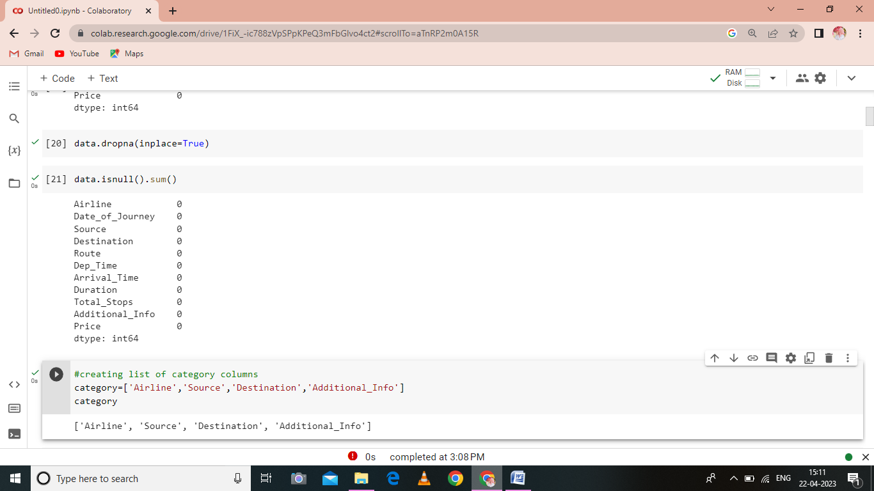

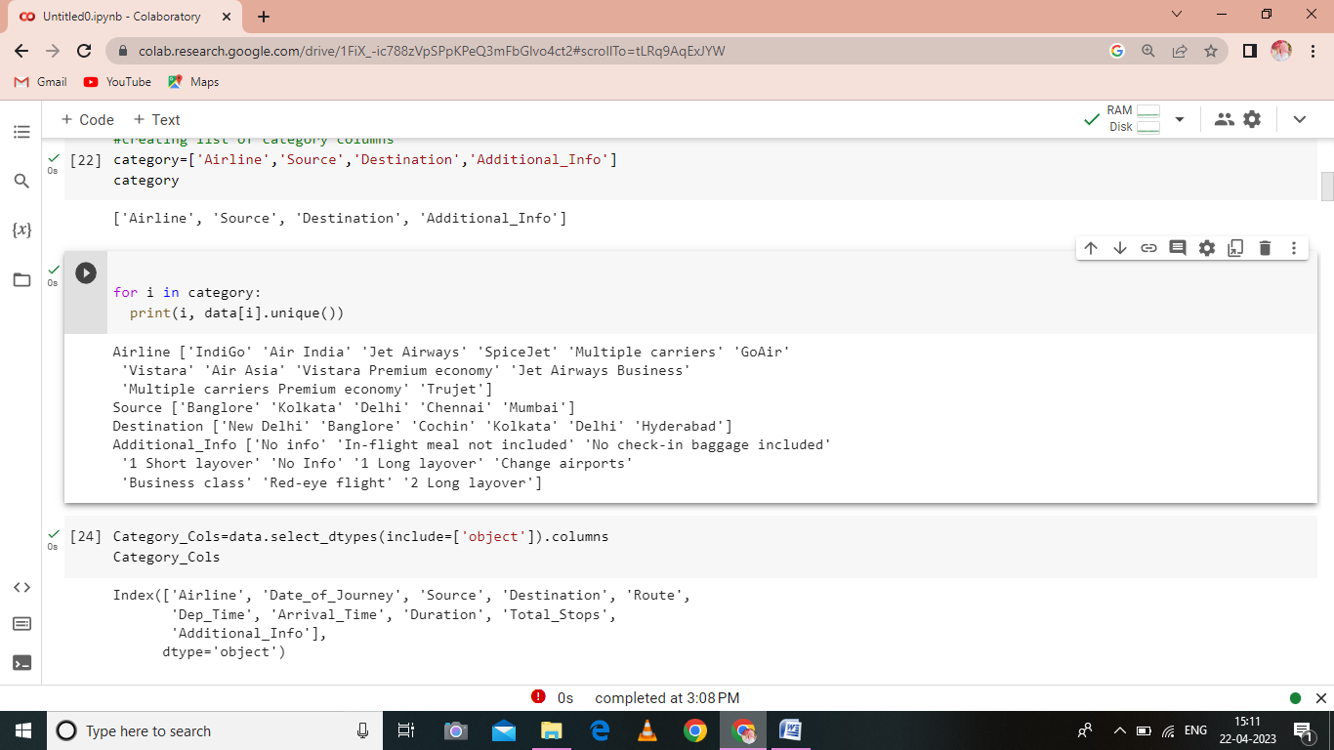

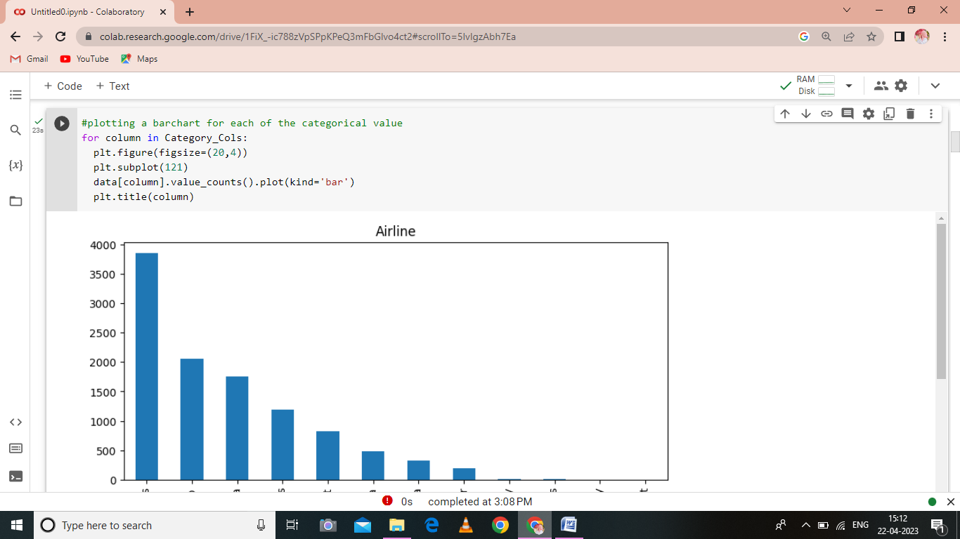

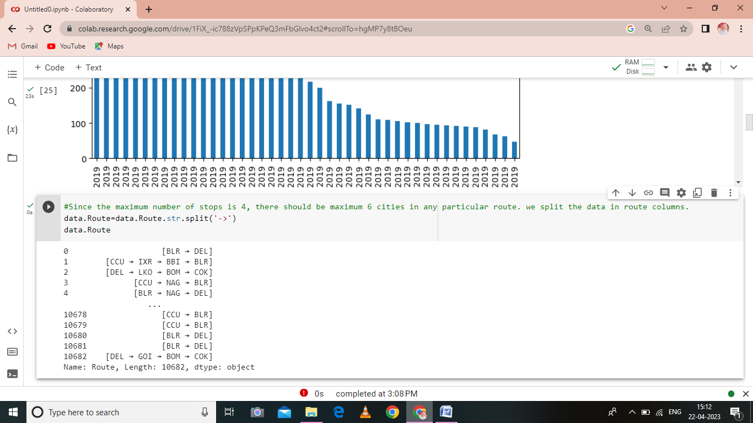

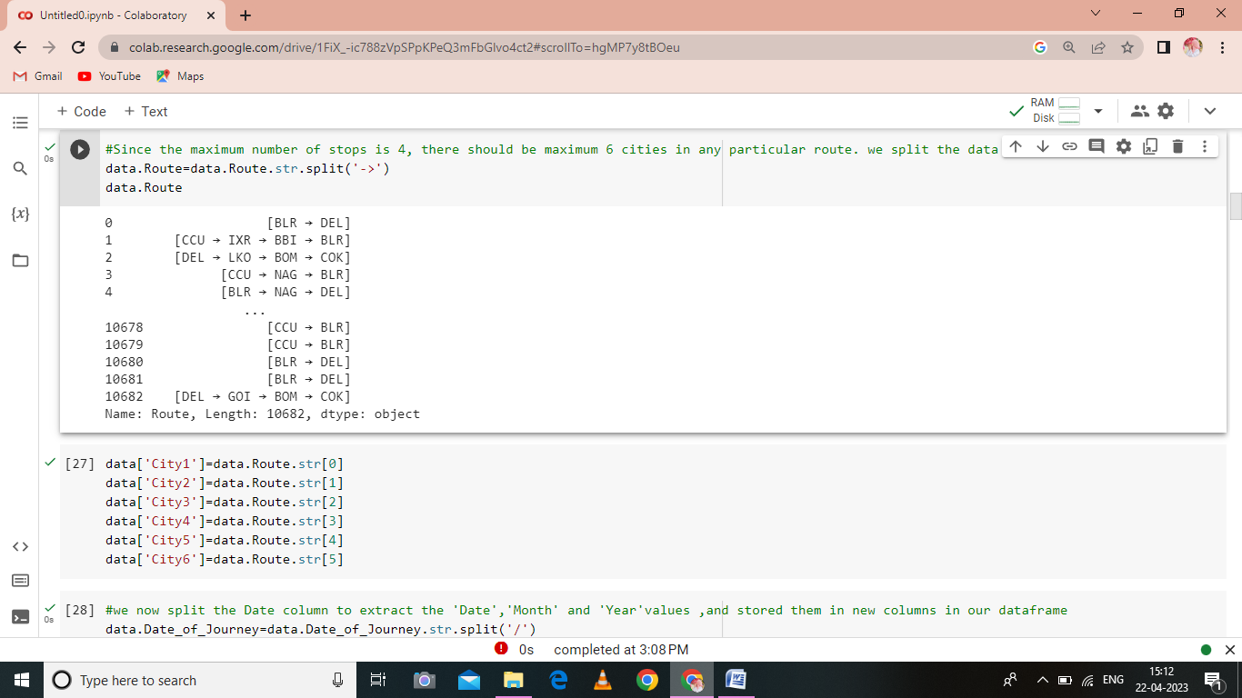

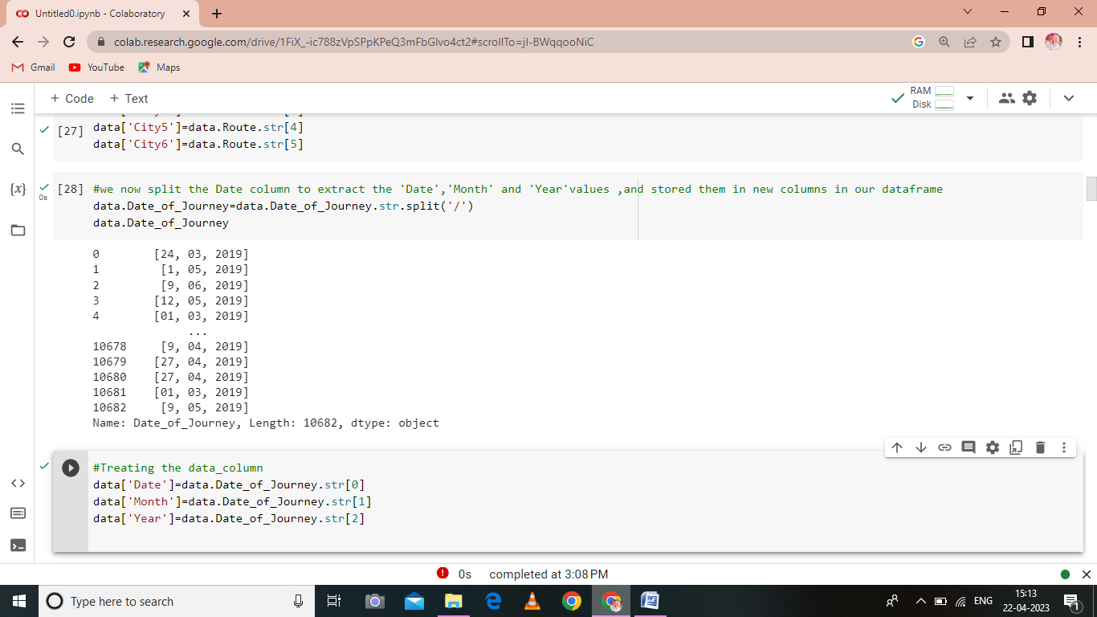

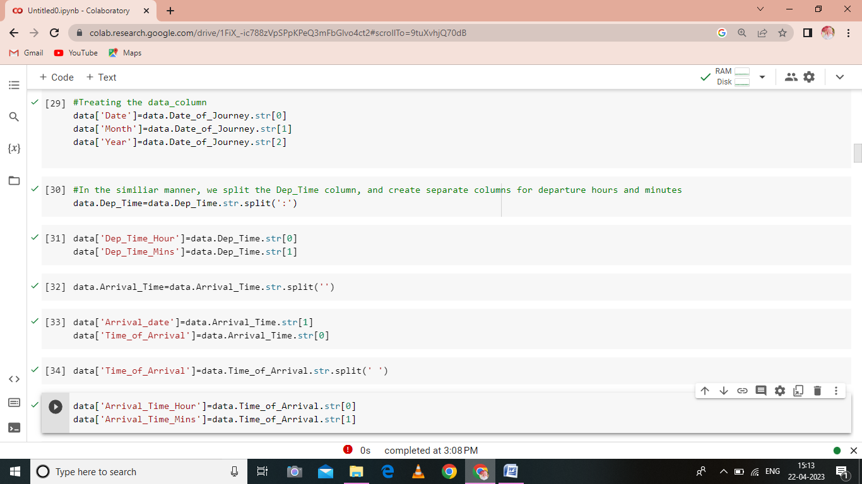

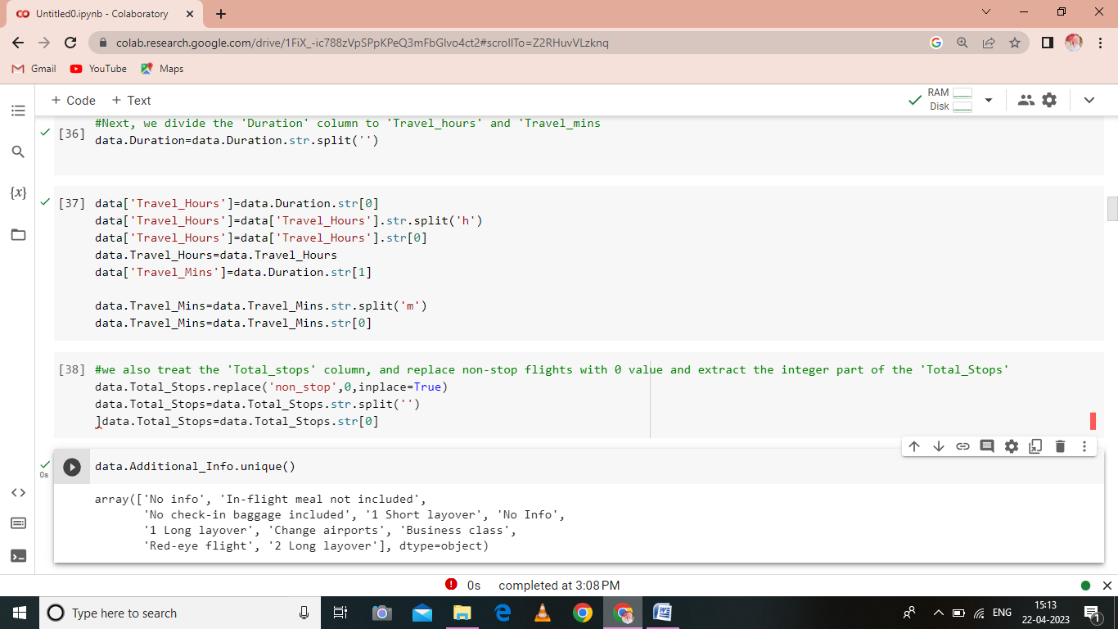

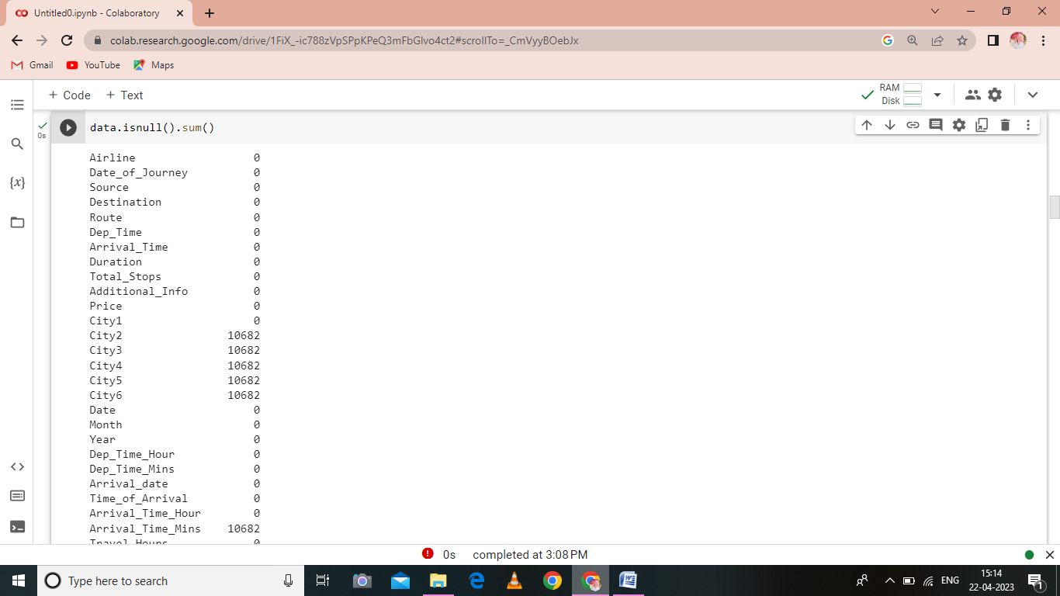

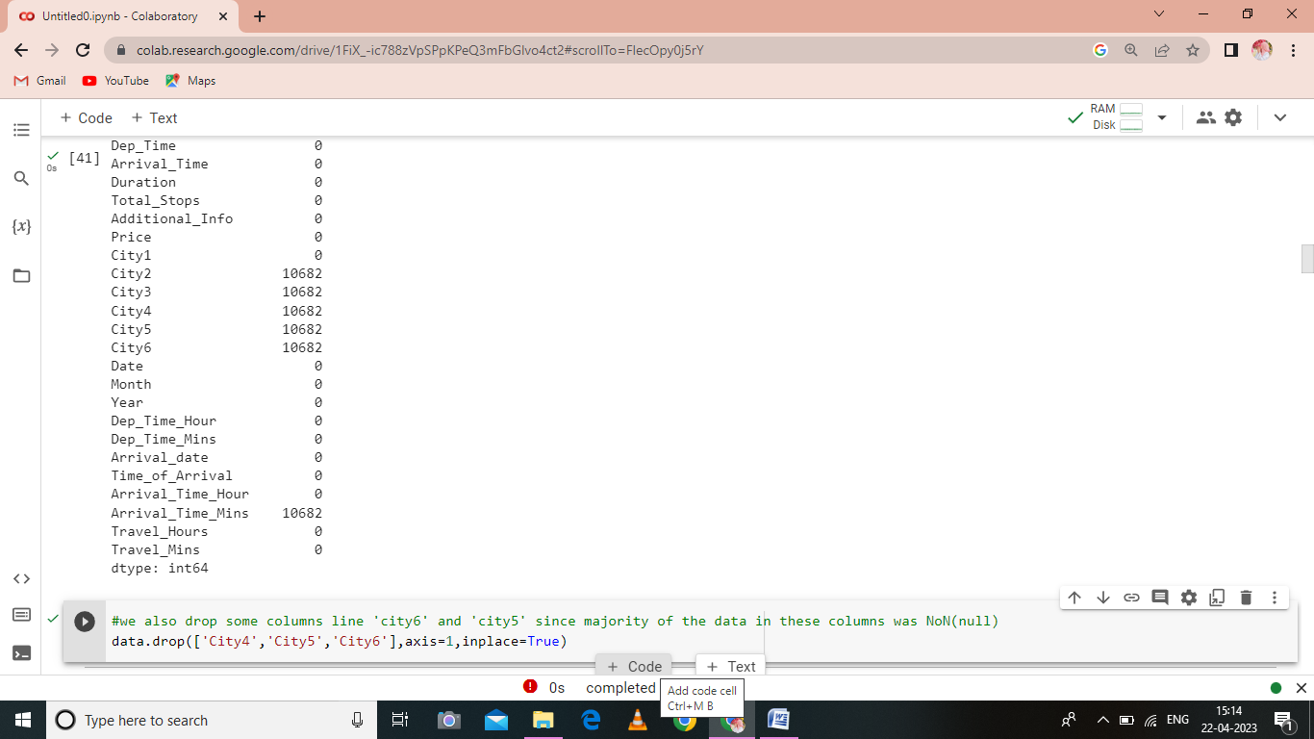

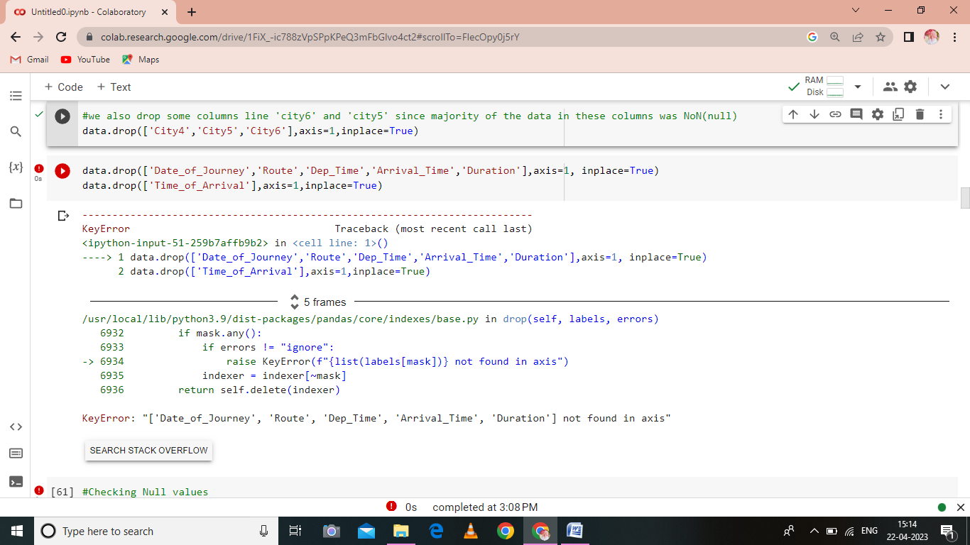

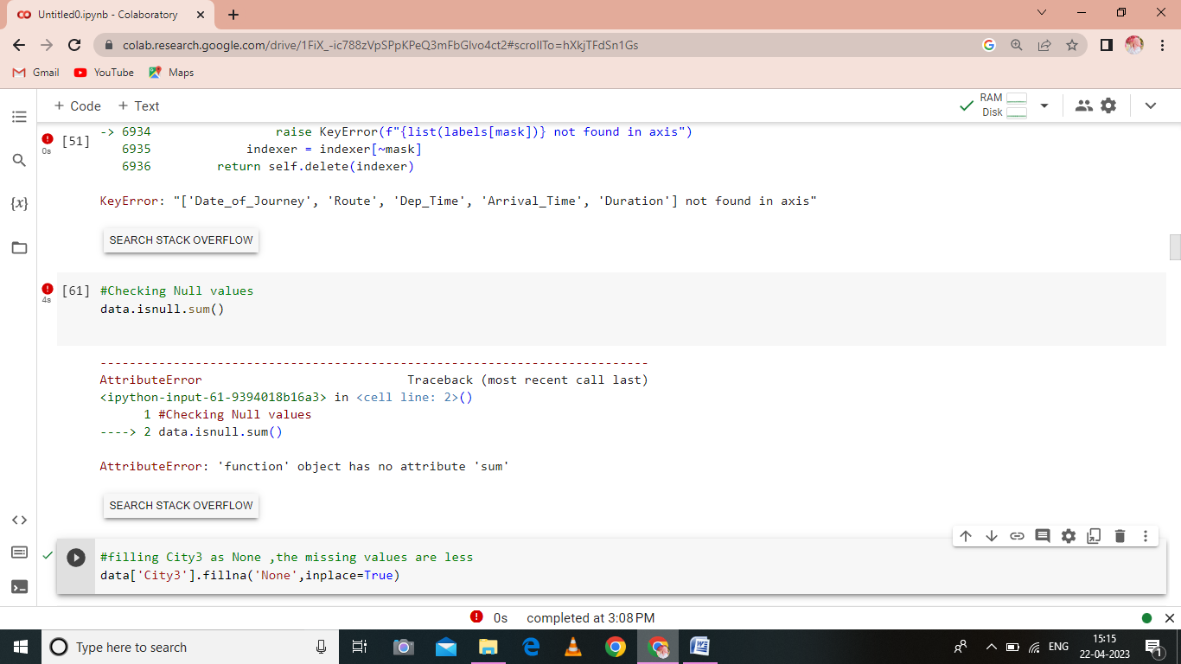

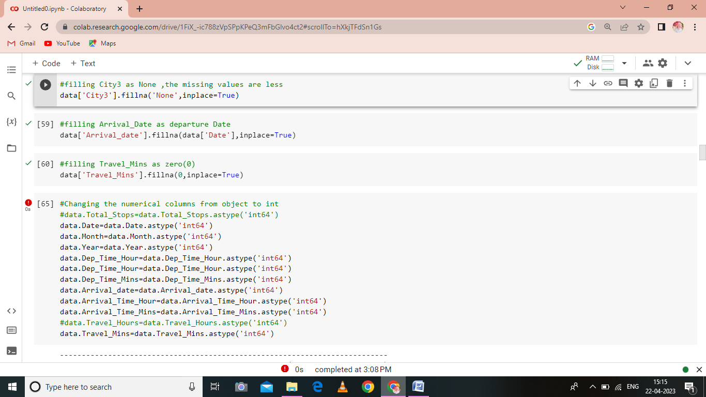

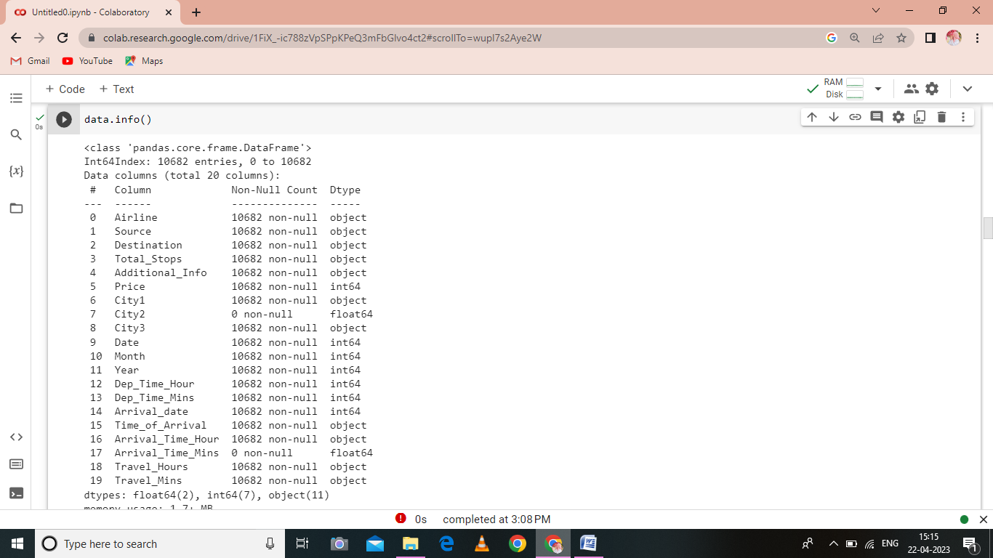

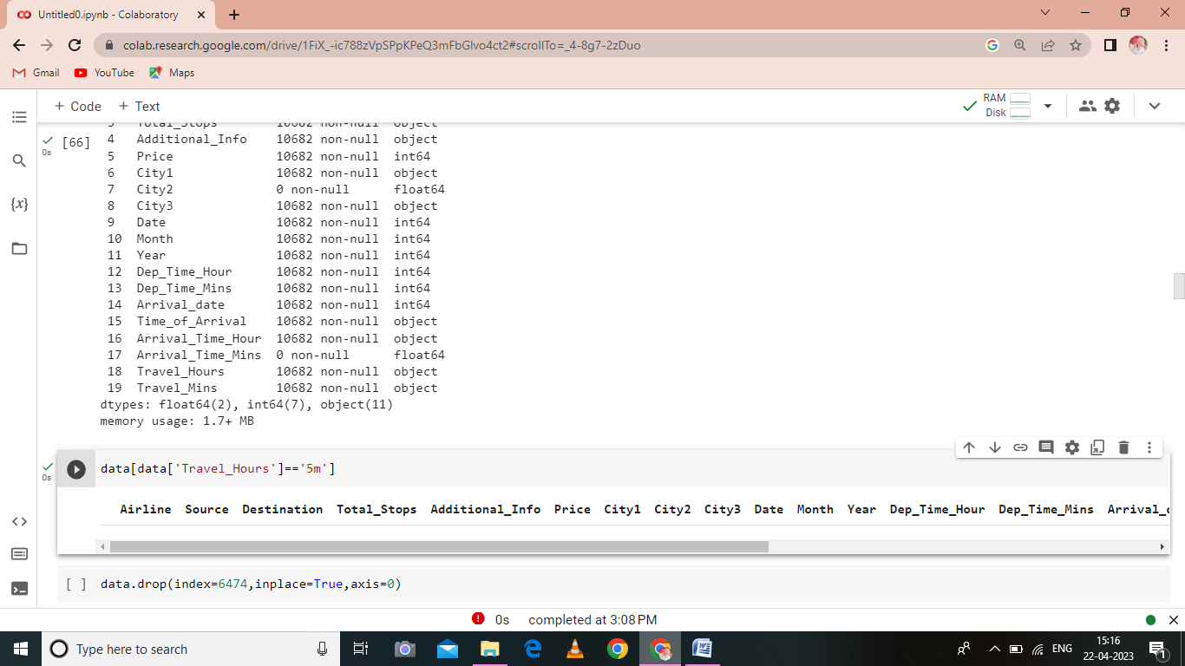

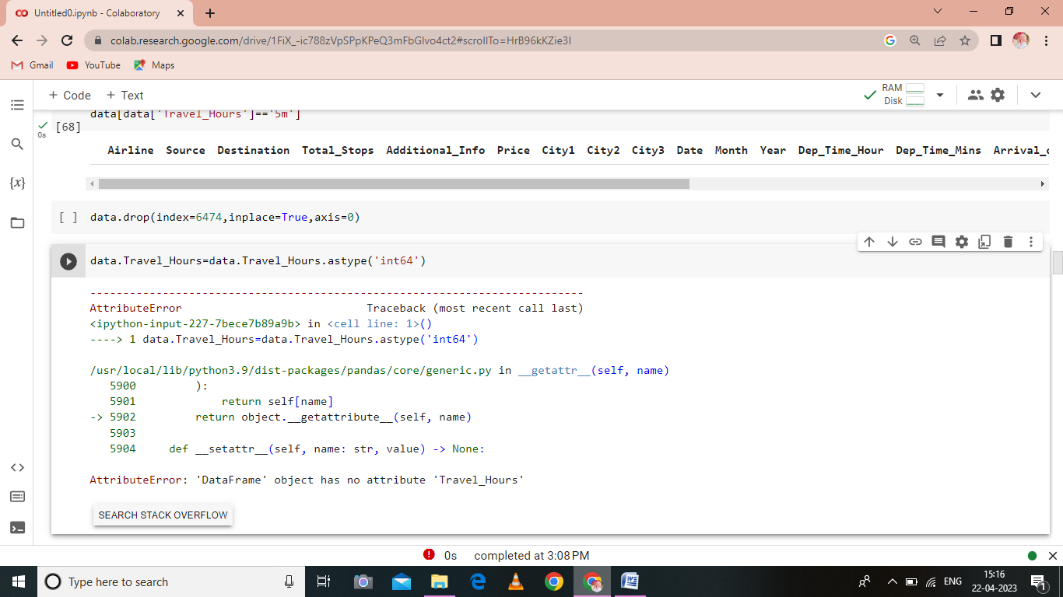

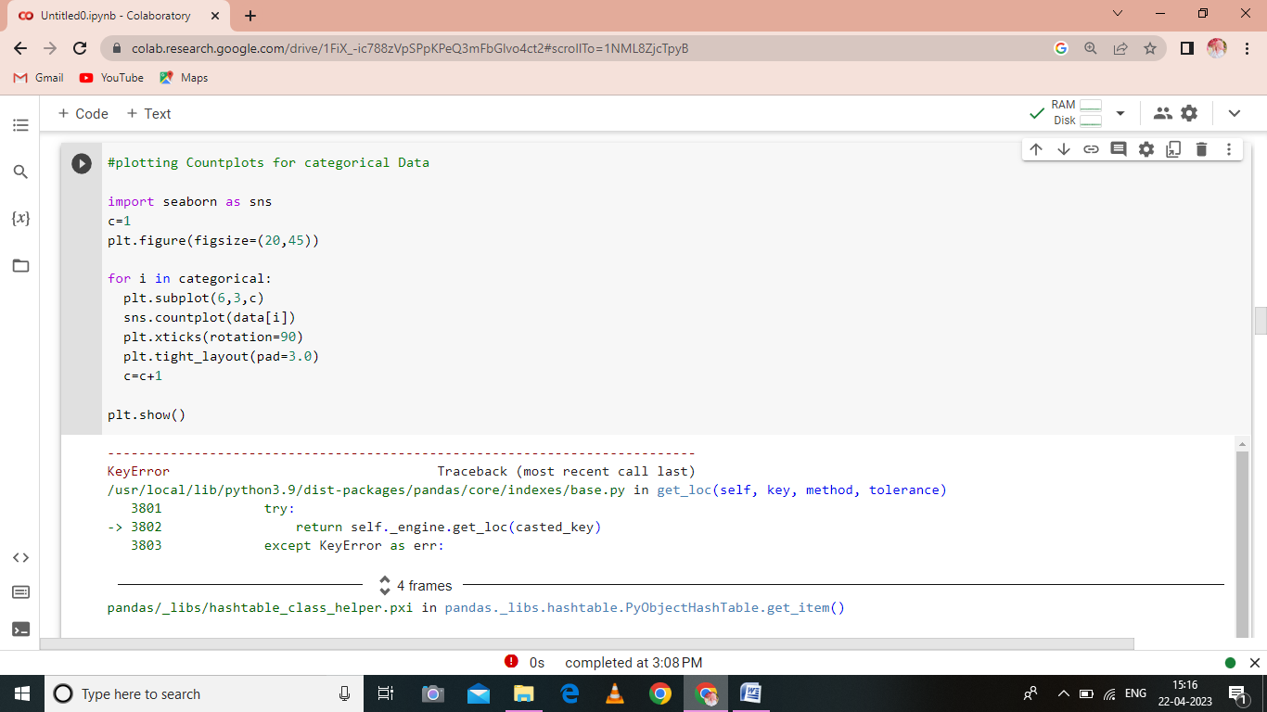

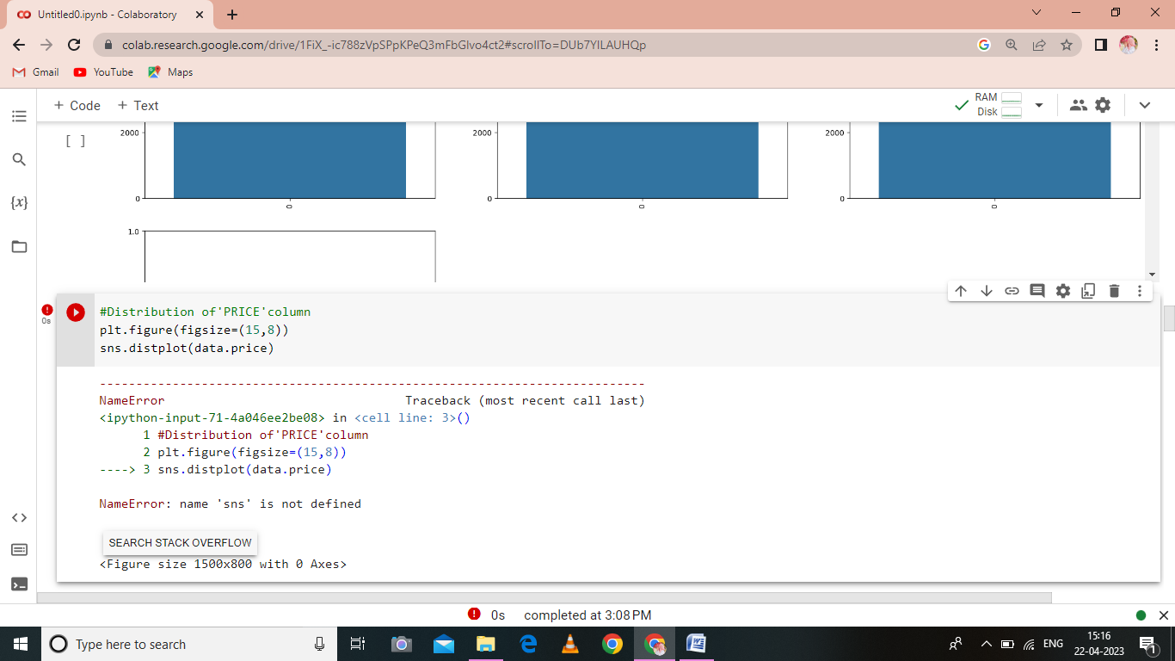

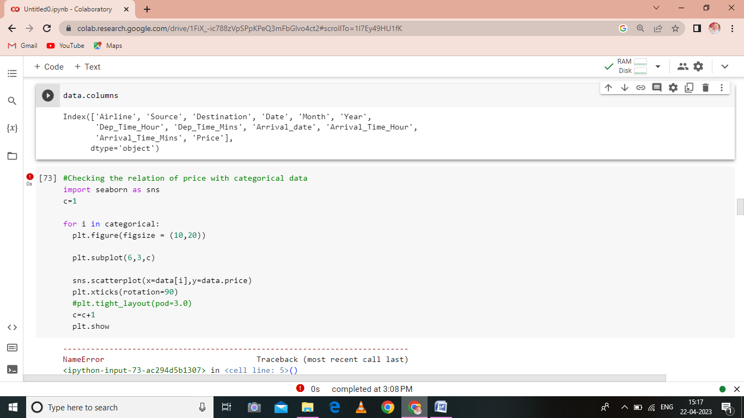

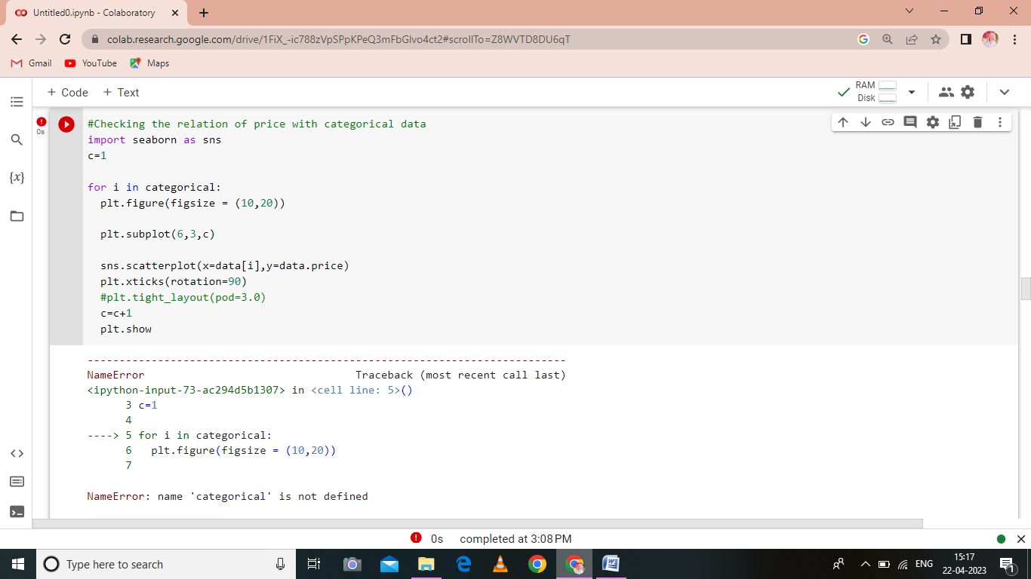

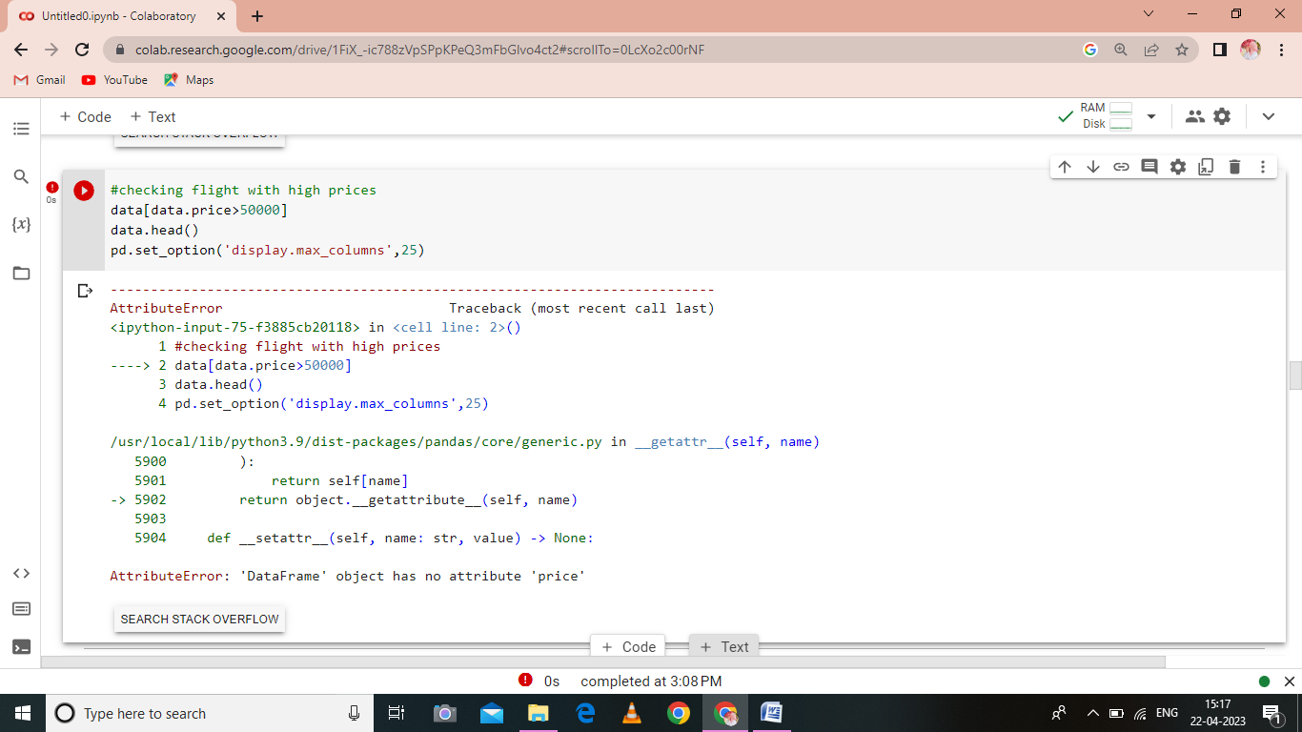

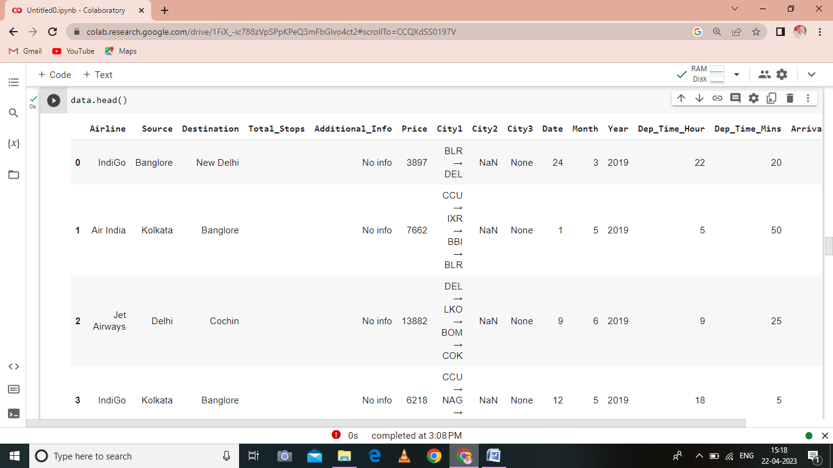

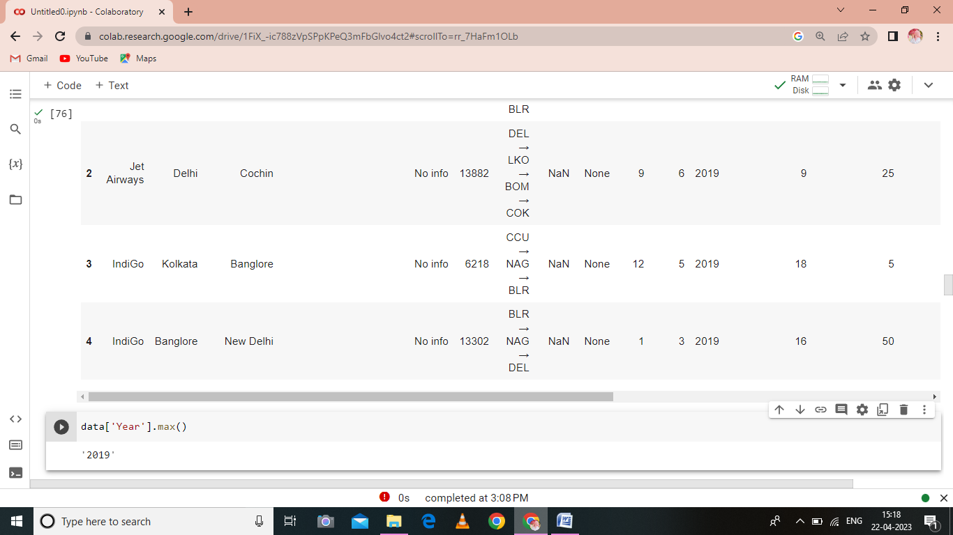

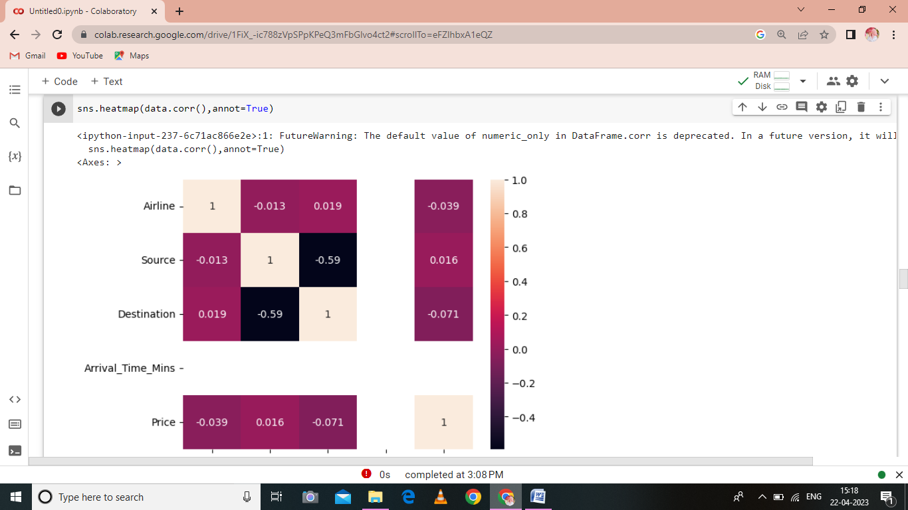

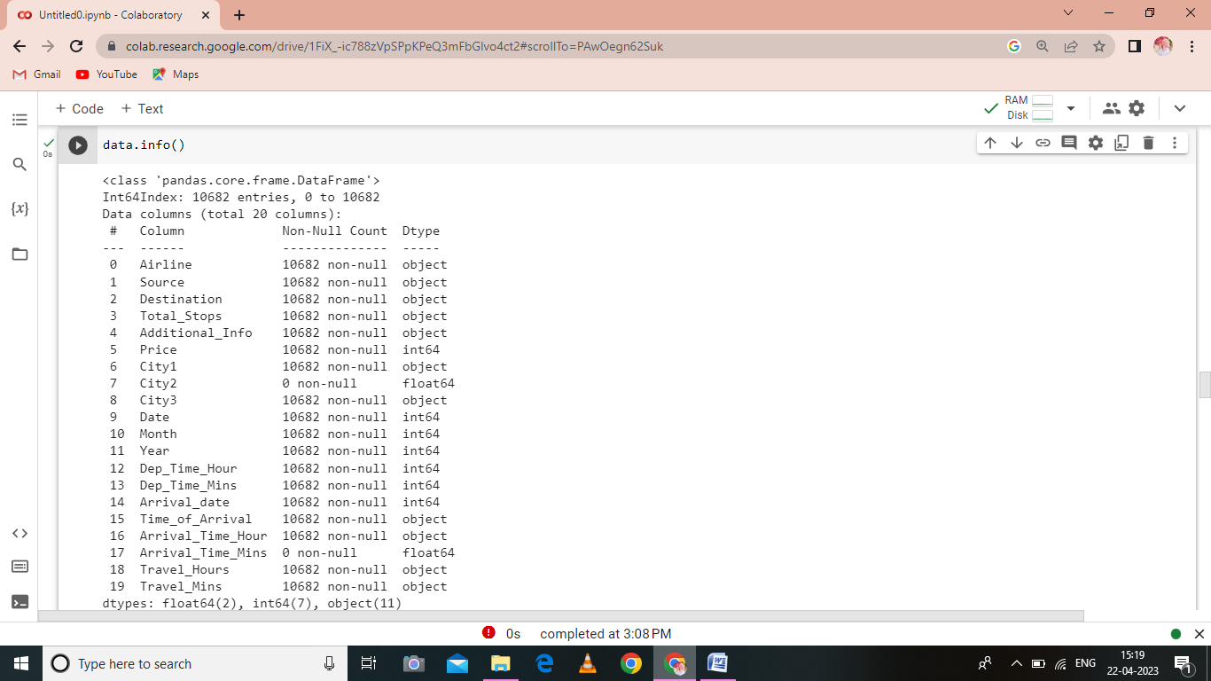

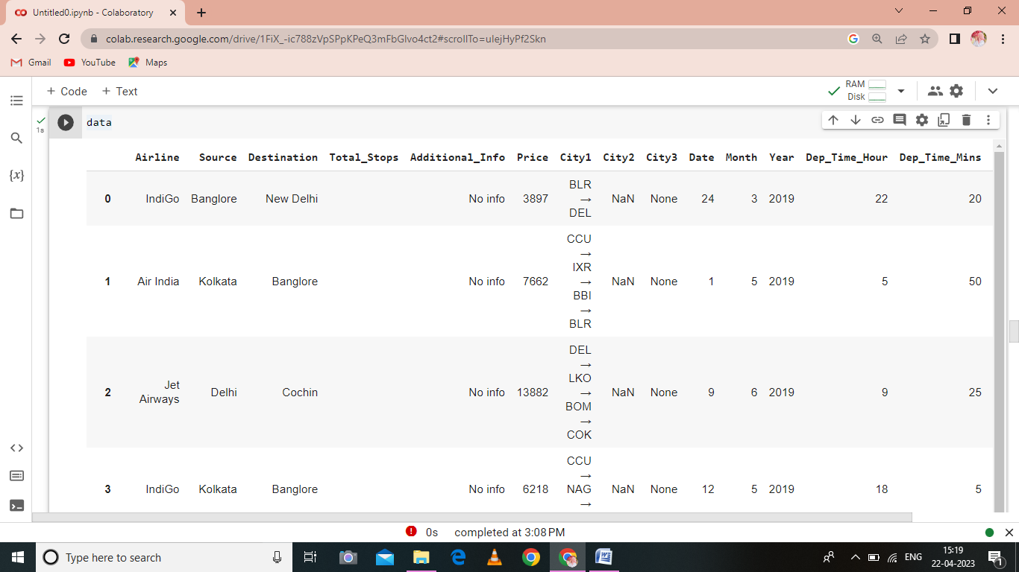

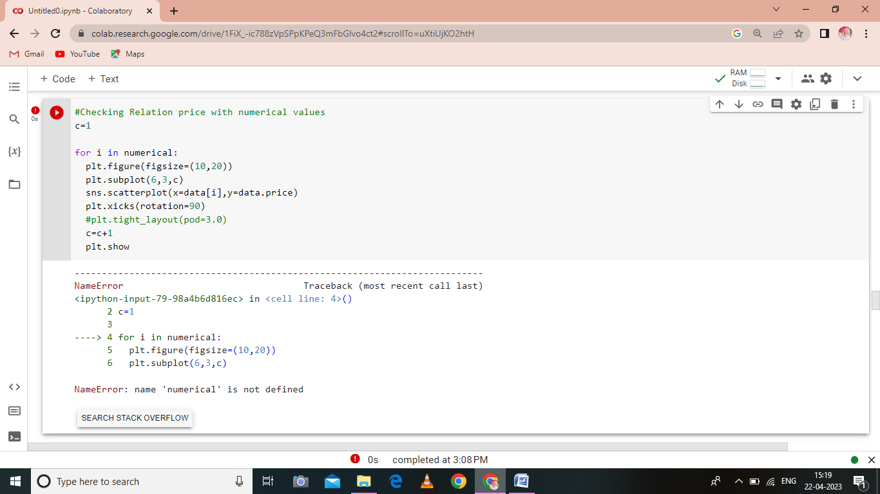

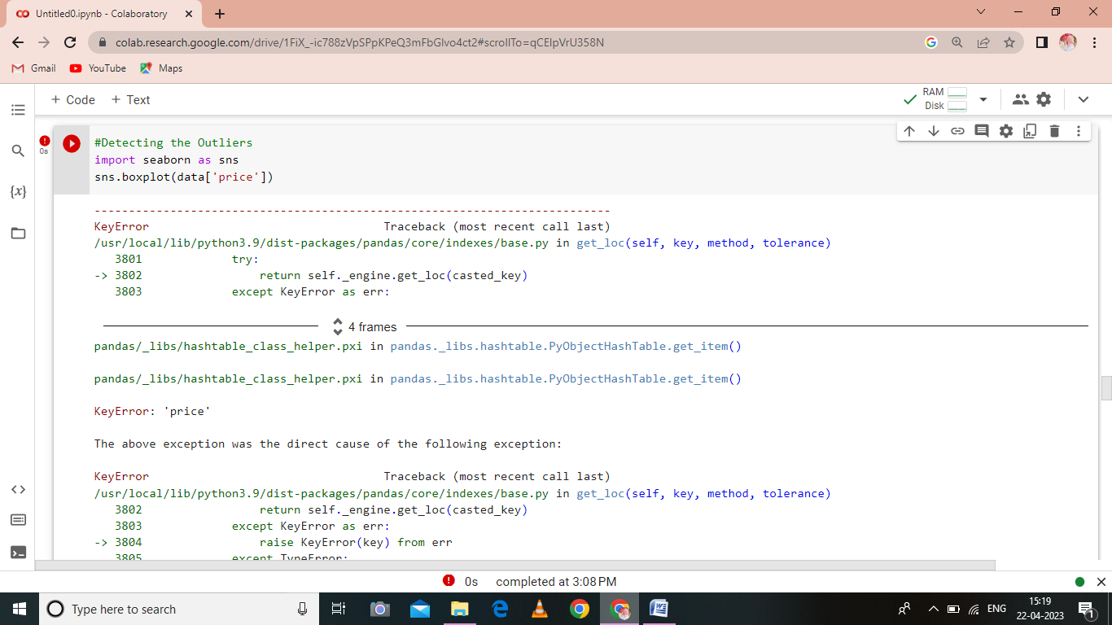

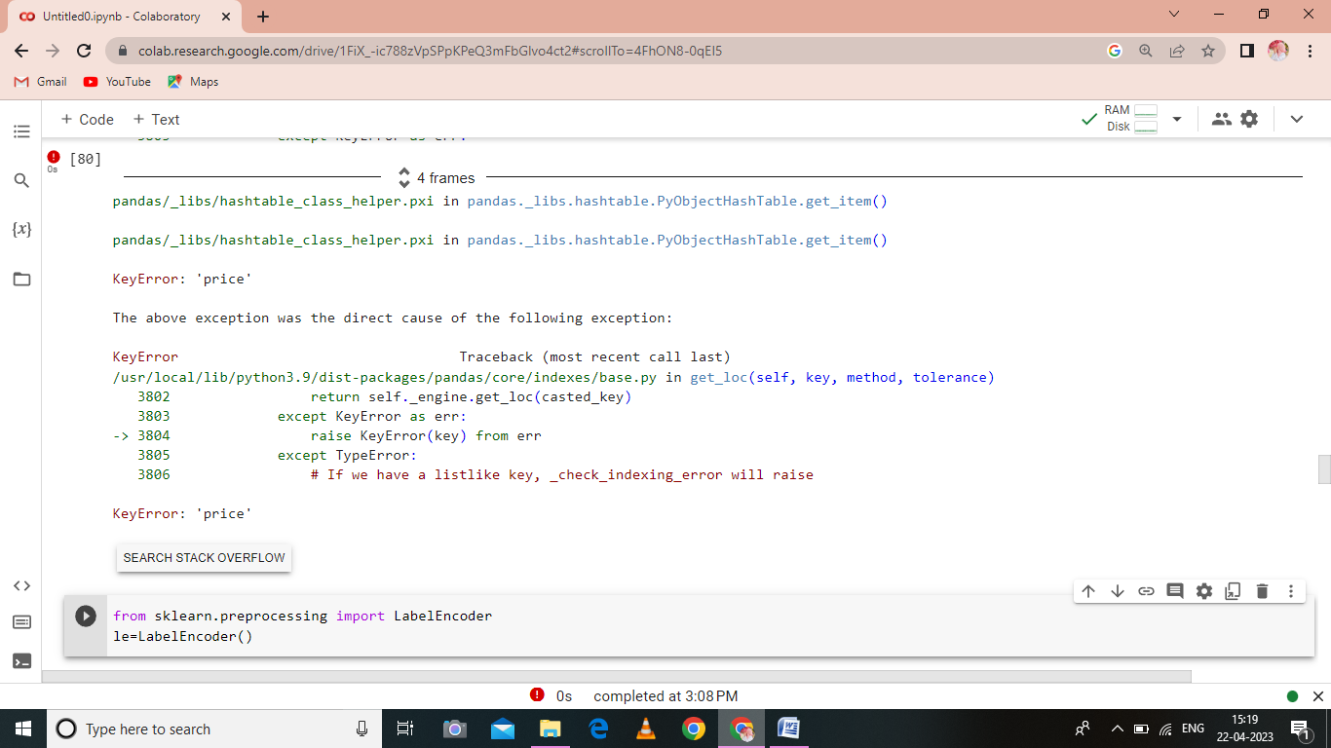

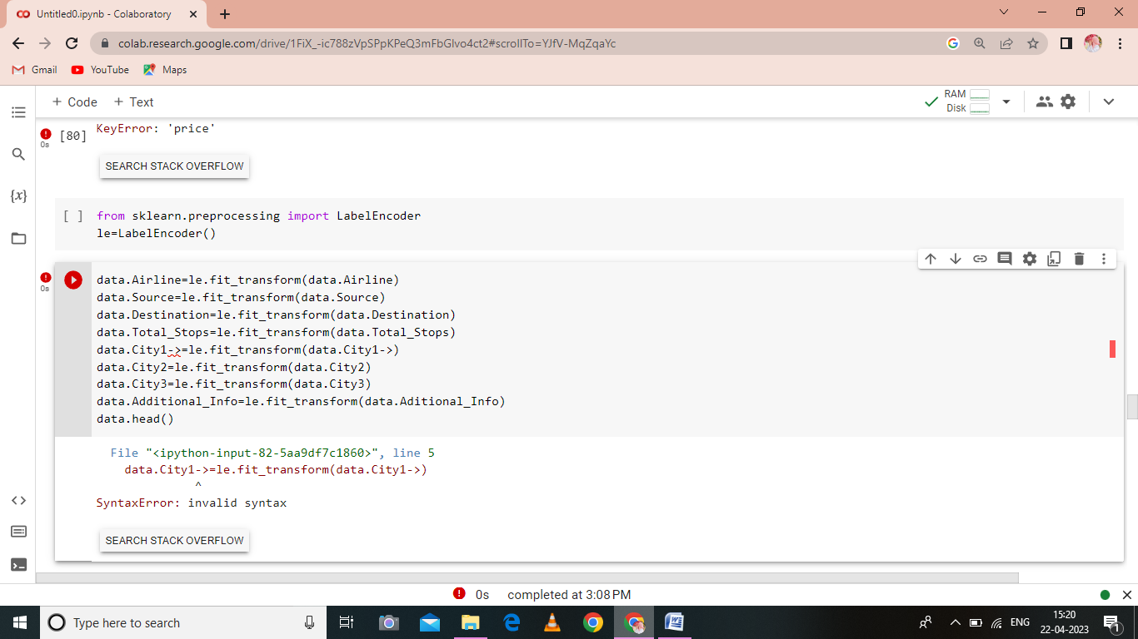

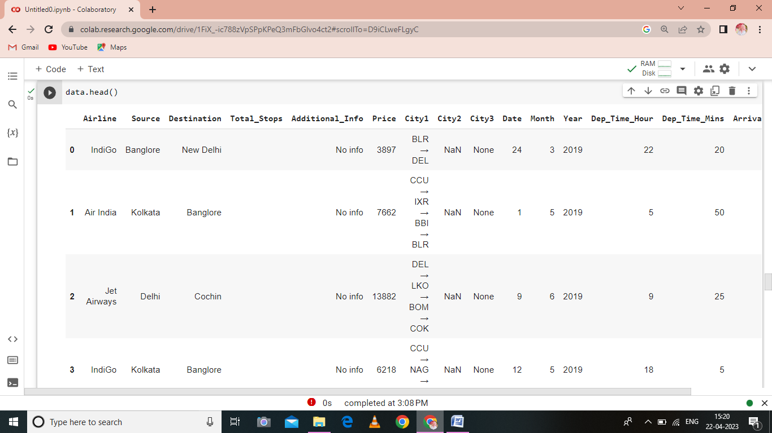

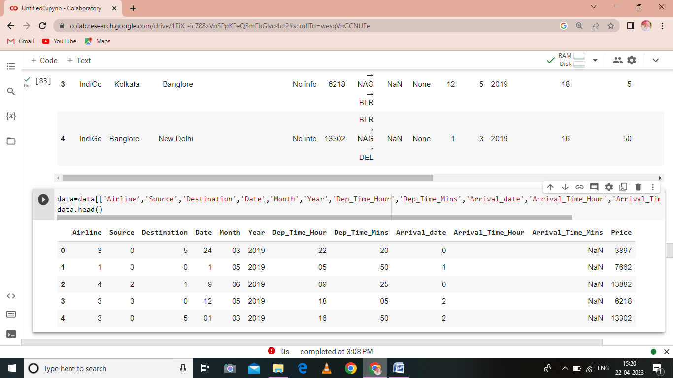

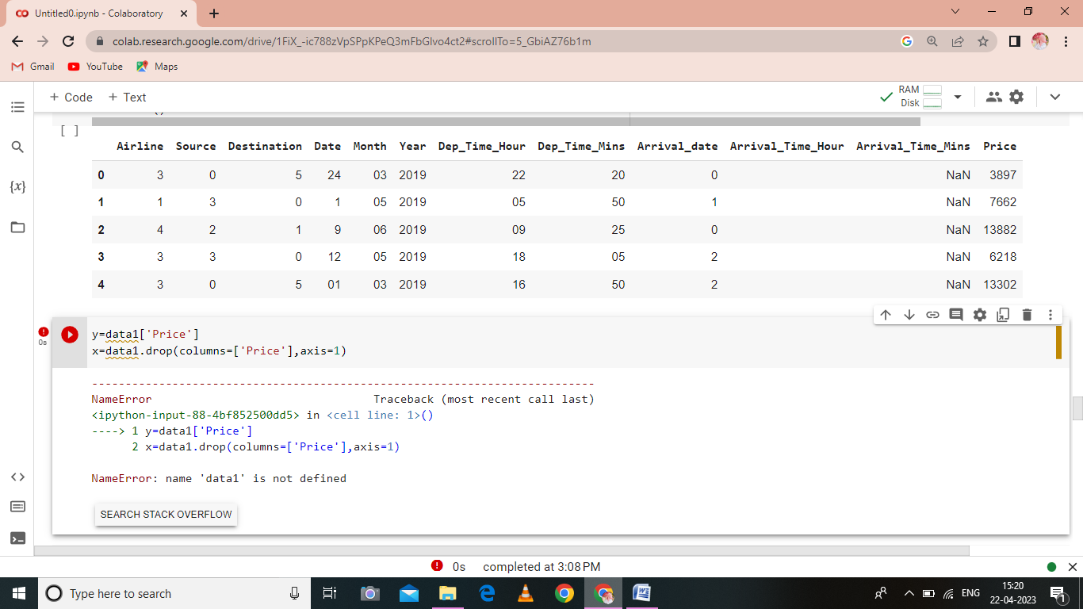

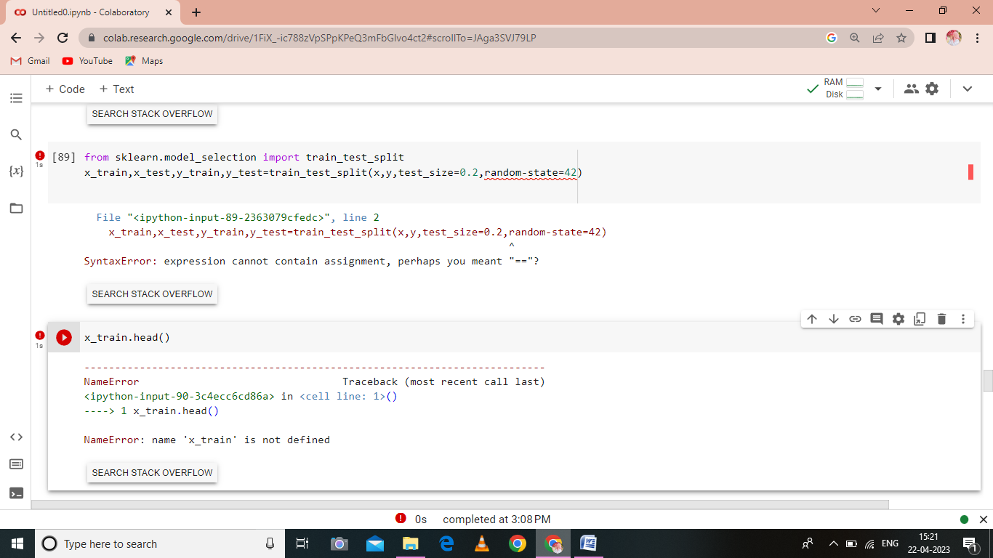

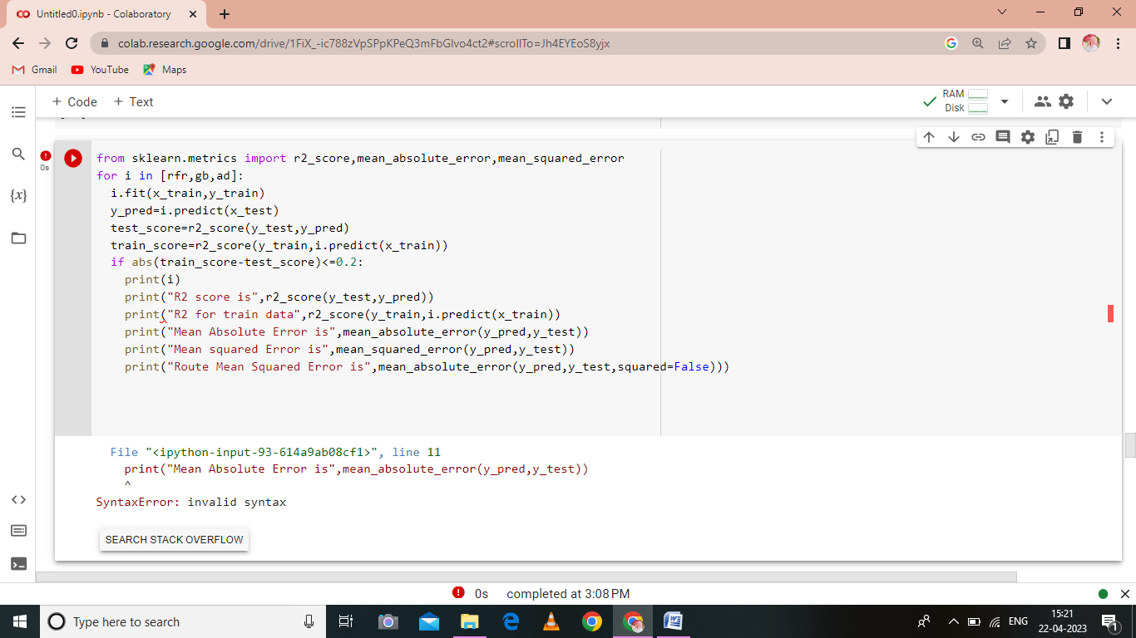

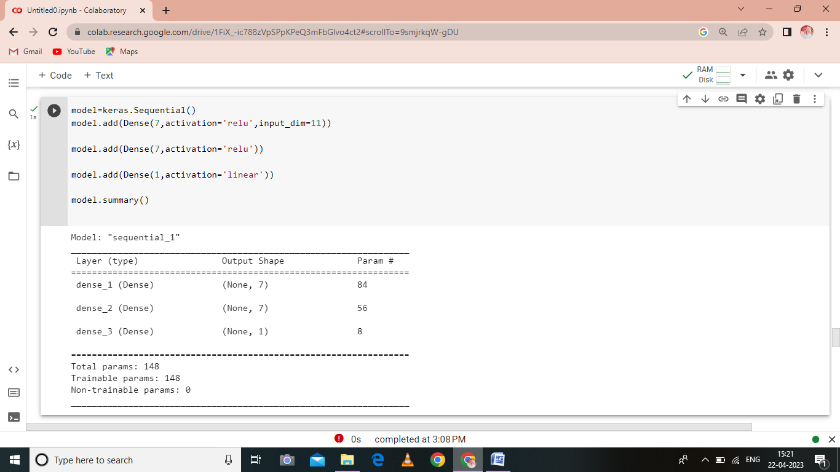

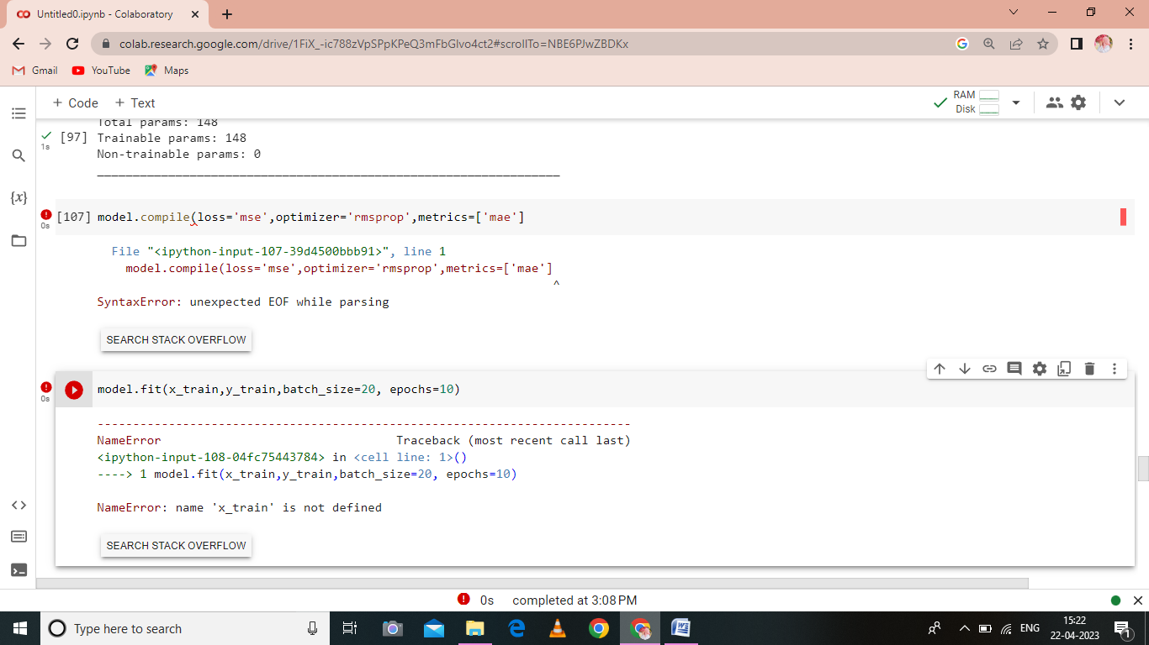

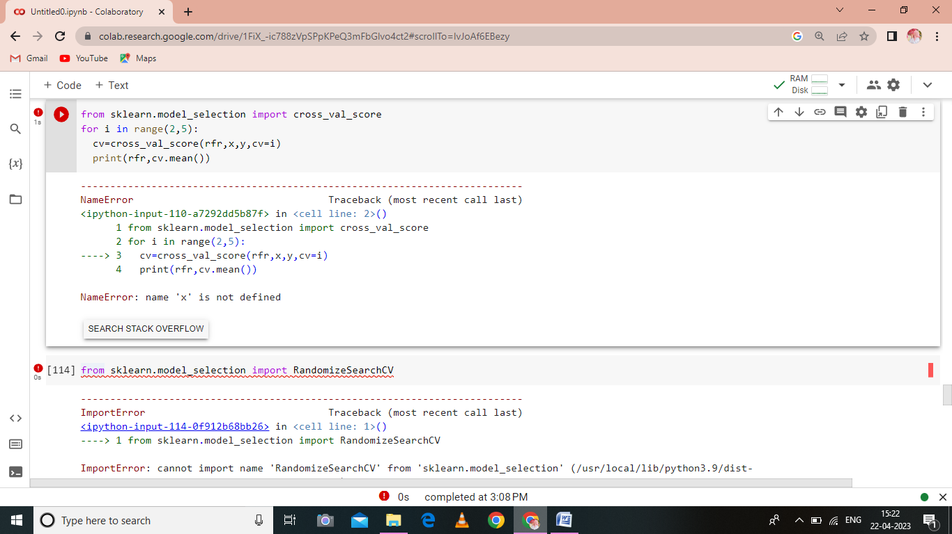

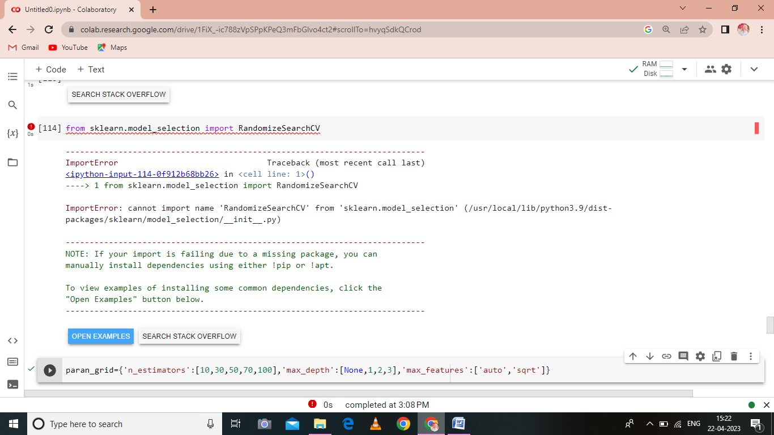

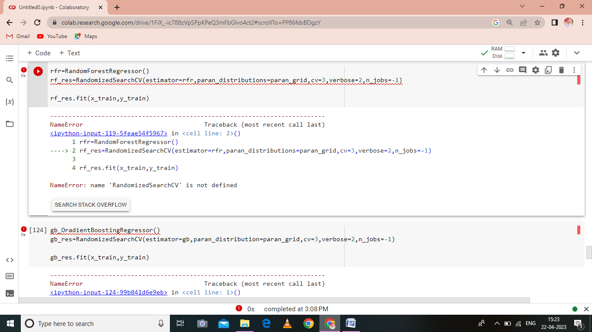

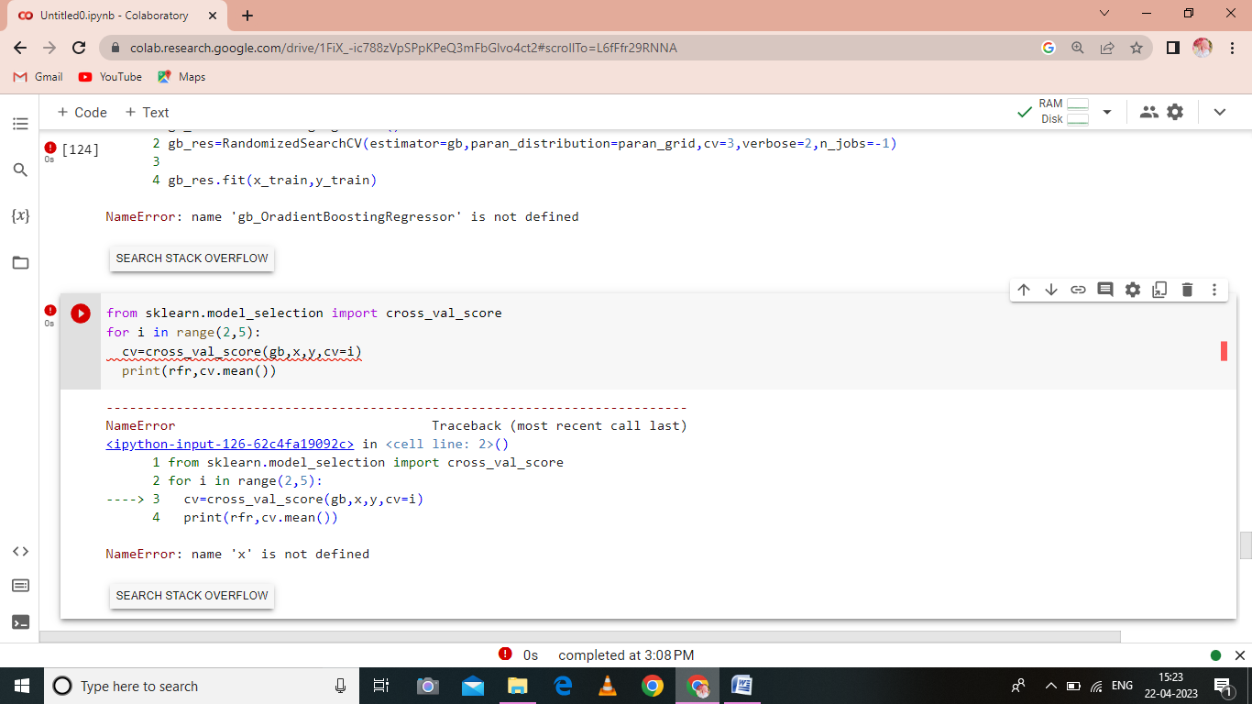

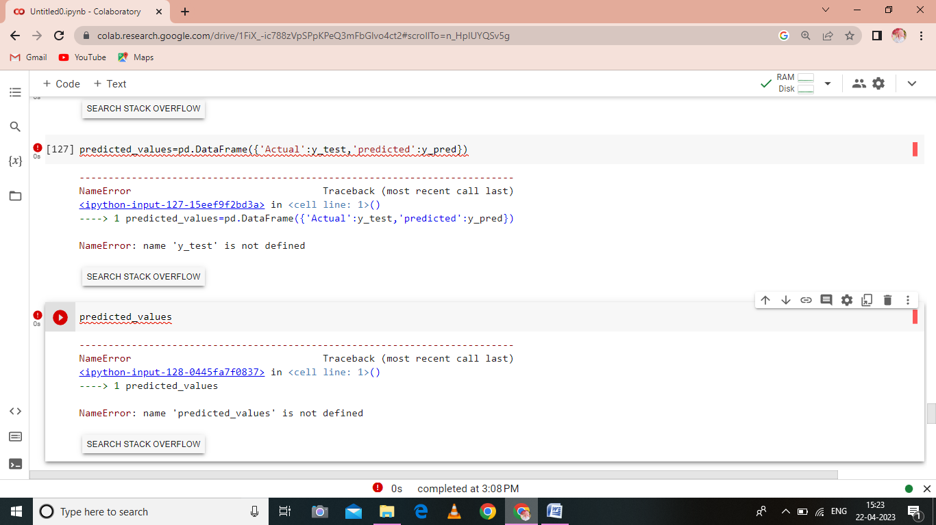

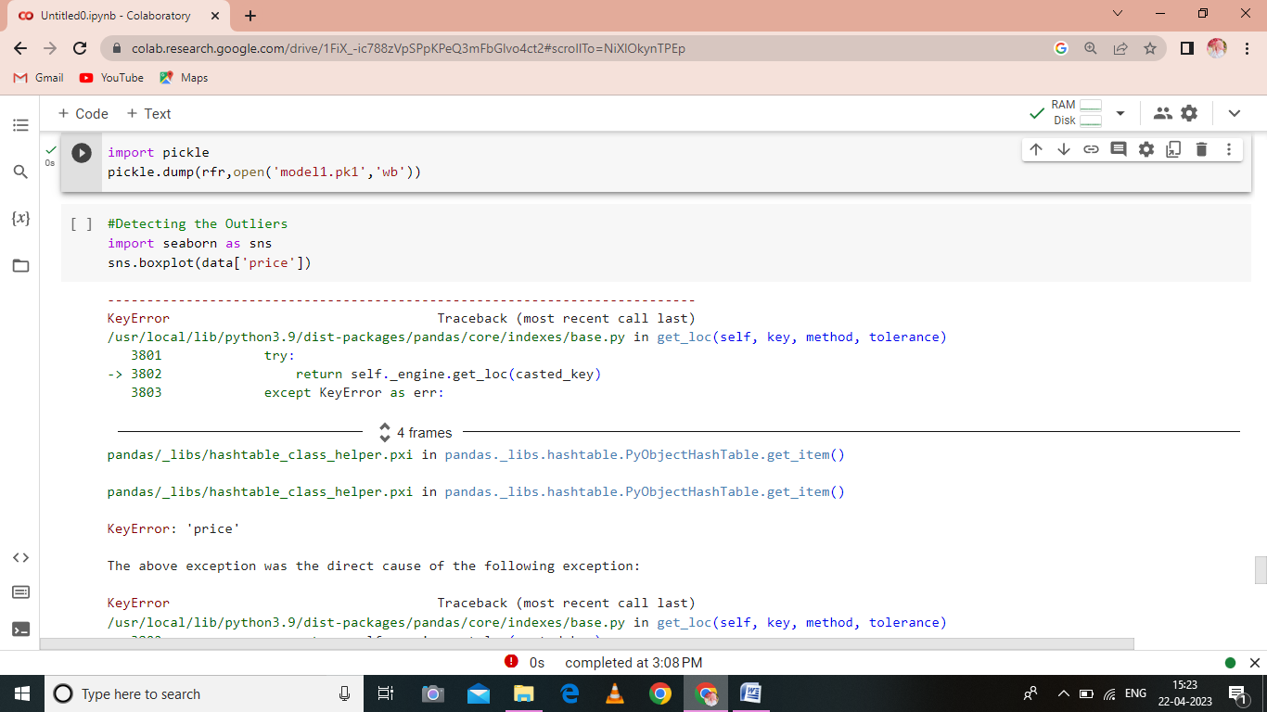

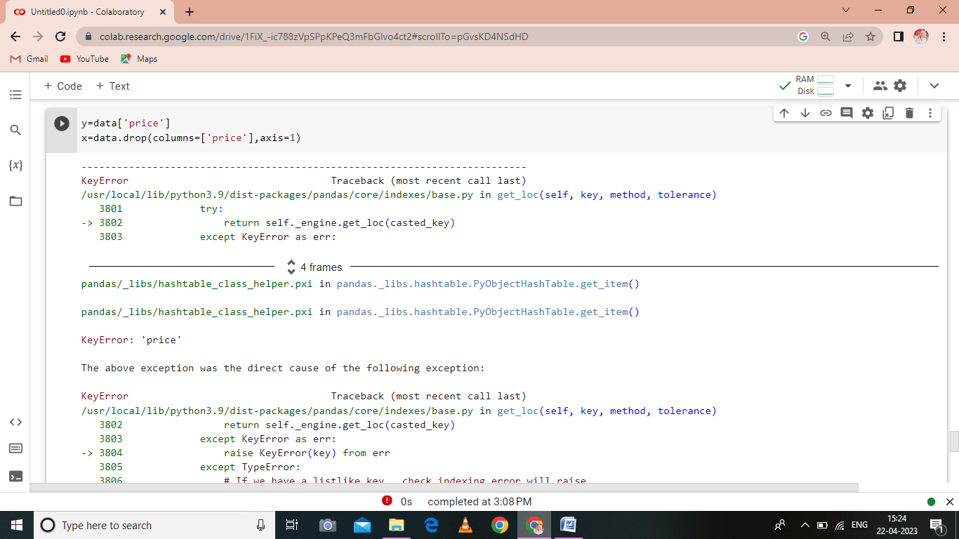

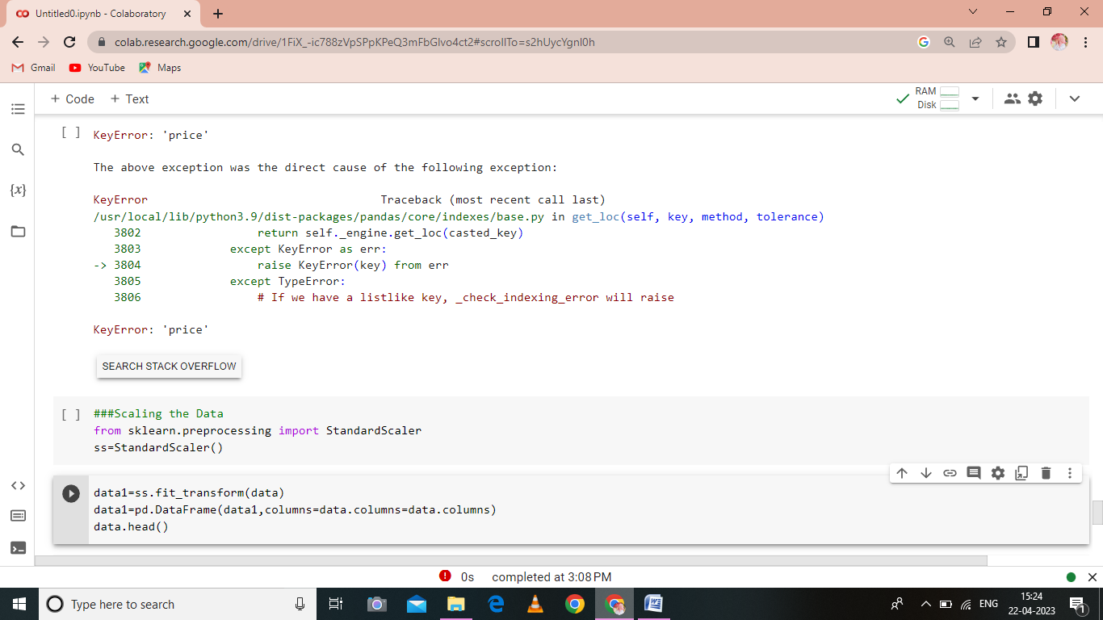

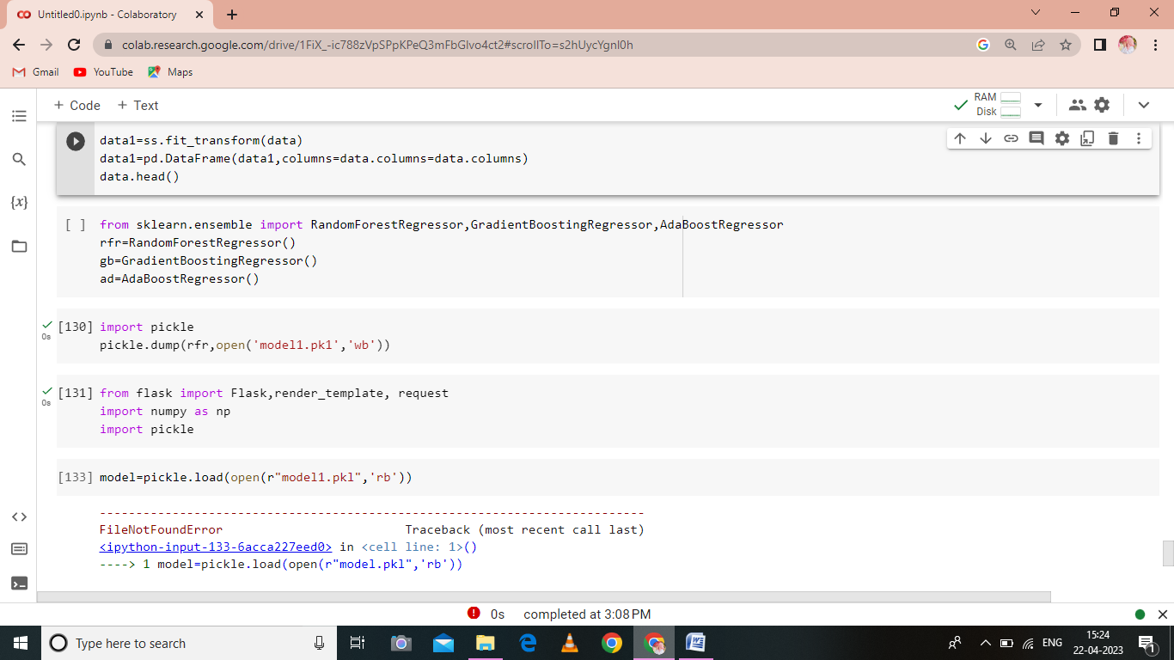

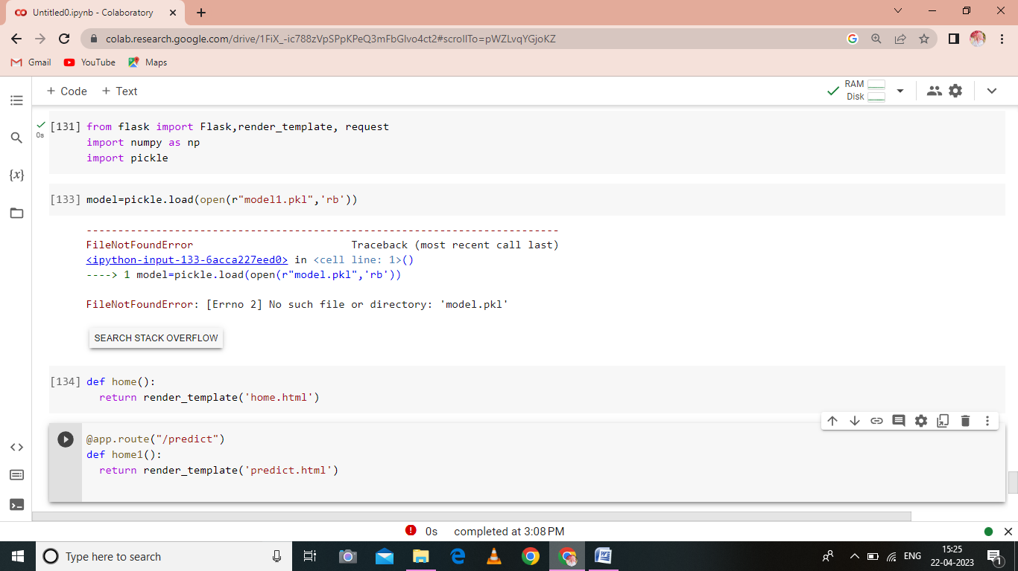

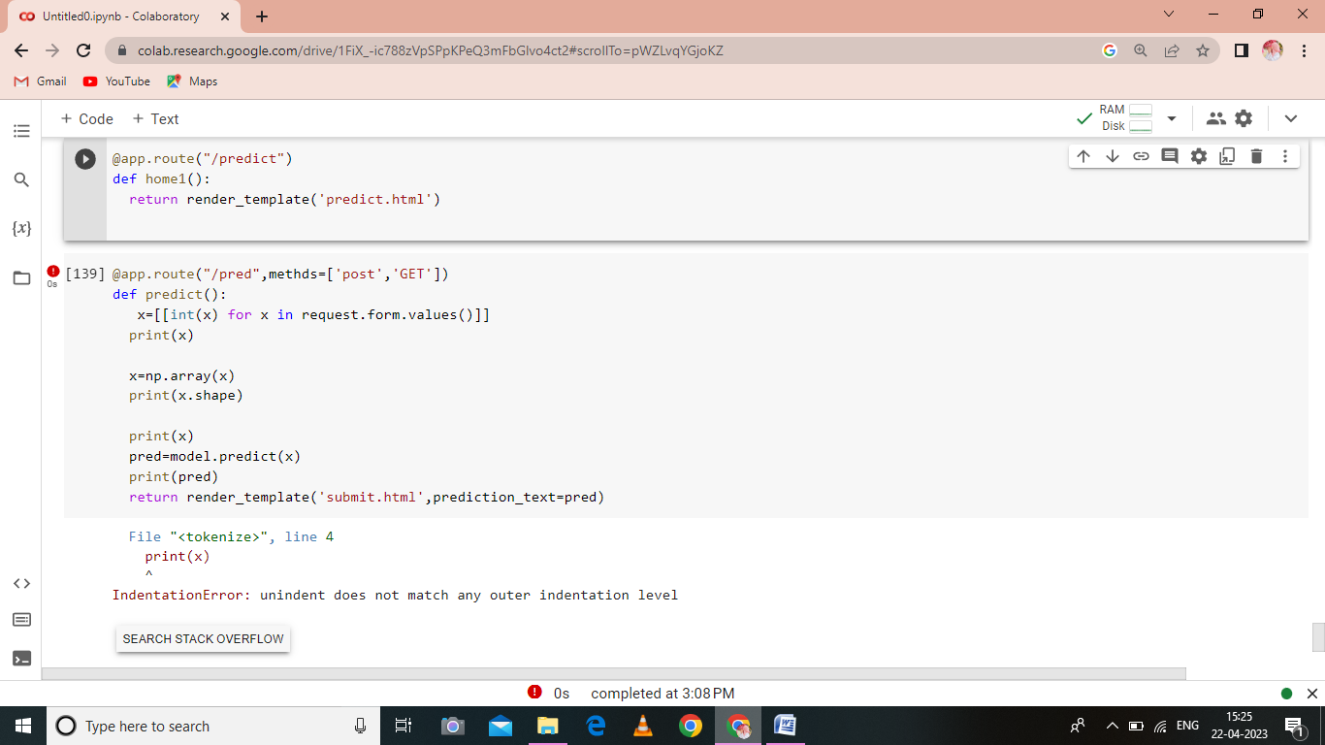

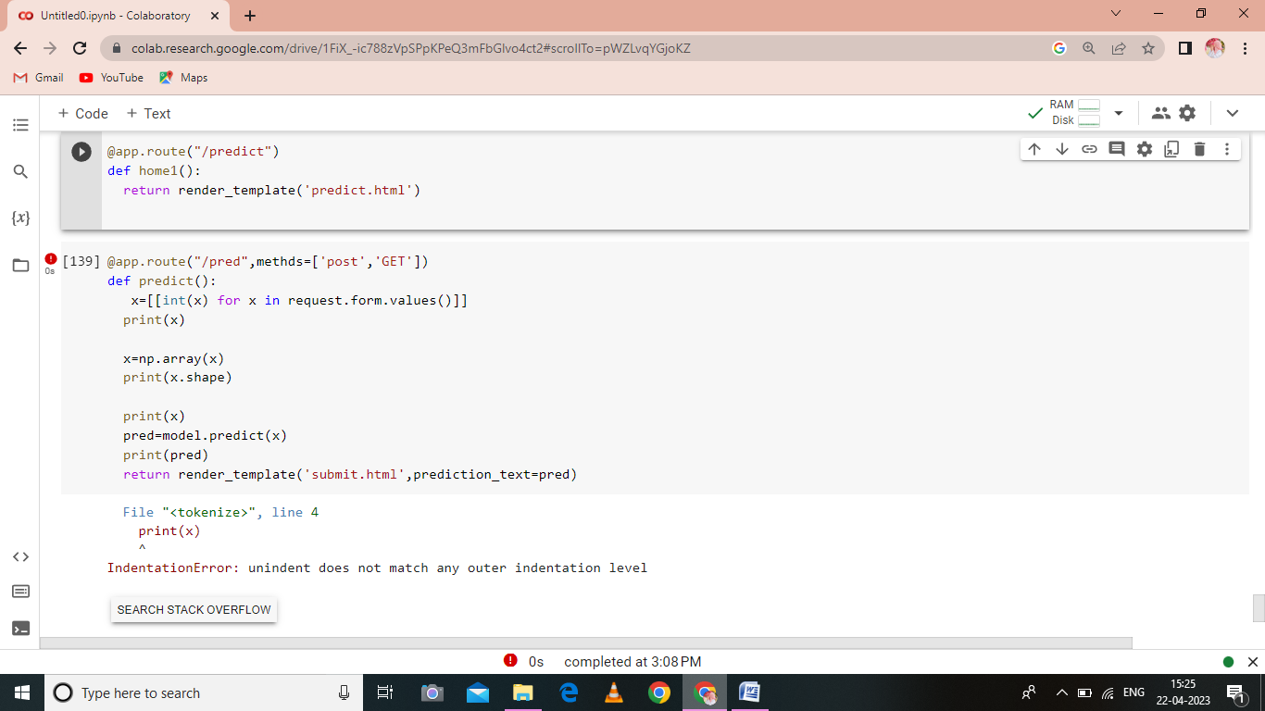

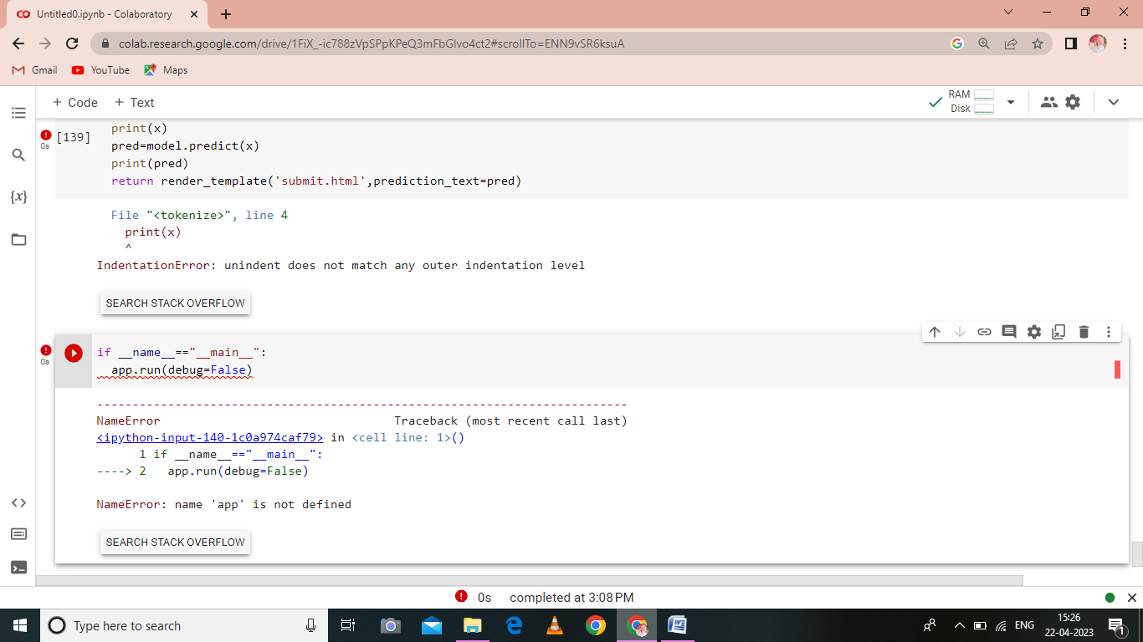

**ADVANTAGES AND DISADVANTAGES:**

**ADVANTAGES:**

* + - **Cancelation and Changes of Travel**
    - **Early Check-Ins**
    - **Maximize Efficiency**
    - **Special Amenities or Deals**
    - **Time Saver and Less Hectic**

1. **Cancelation and Changes of Travel**

It is normal for travelers to cancel or change their

online reservations. They will not have to call their airlines and wait for a service representative to give them a hand.  
 Booking a flight online means you may do everything provided have internet access. Some airlines offer bookings without cancellation fees, while others provide online cancellations and changes for free, as long as you do it within 24 hours of departure.

1. **Early Check-Ins**

If you want to fly within the country, you might check-in in advance and as late as one hour before taking your flight. On the other hand, [**international flight booking**](https://www.cleartrip.ae/flight-booking/international-airlines.html)allows travelers to check in between three and 24 hours before taking their flights.  
All you need to do is visit the site of your preferred airline and find your reservation so that you can enter your details. Main airlines also provide mobile check-in options, where travelers will receive a bar code on their phones.

1. **Maximize Efficiency**

There are a lot of aspects of booking online, which have been automated. Time is valuable, and all the time you spend unnecessarily to put information into booking flights can be spent assisting customers in the queue.

**4. Special Amenities or Deals**

From time to time, airlines provide loyalty bonuses and other additional benefits for online booking. These may range from free Wi-Fi, beverage credits, and food to additional miles and special packages.  
 These benefits and deals will motivate you to book directly since they might not be available through third parties.

**5. Time Saver and Less Hectic**

The internet has everything, so you may easily create packages from scratch based on your personal preferences, dates, and budget. You will also find affordable flights ready tailored to concert tickets, booking hours, and museums.  
Hence, there will be no need to reach out to a representative and wait to receive feedback. Online booking allows you to reserve a seat any time of the day.

**DISADVANTAGES**

* If you make a mistake, while you re booking, for example spell your name wrong, you re done, your ticket is not vallied and you are charged.
* There is usually nobody you can turn to, in case of a problem with the flight.
* If you want to claim, after the trip, or something went wrong with the trip, your claim is kind of in the air. Nobody is really responsible. The airline itself: Where did you buy the ticket? Ok. claim there. But there is nobody to address to. Yeah, that’s YOUR problem.
* Where you bought your ticket? There is nobody at the airport representing the company who sold you the ticket.
* There are about 4000 booking sites and engines. Hardly any of them inform about travel conditions, for example visa and other restrictions. Most call centers and all agents do that.
  1. **APPLICATION**

In this section, we will be building a web application that is integrated to the model we built.

A UI is provided for the uses where he has to enter the values for predictions.

The enter values are given to the saved model and prediction is show caed on the UI.

**This section has the following tasks:**

* Building server side script
* Building HTML pages
* Run the web application

**6. CONCLUSION**

Justify the creation of a national research program focused on the needs of airport operators;

Reveal how such a program can play a role in helping airport operators meet the many demands of federal agencies, state governments, local communities, and airport users;

Provide guidence on governing, funding, and administering an airport research program.

**7. FUTURE SCOPE**

Emergingtechnologies are reshaping with robotics, artificial intelligence, the internet of things, unmanned aircraft systems and the push for hybrid and electric airplanes just to name a few.

Alternative fuels can significantly change the current scenario of aviation in support of the environmental protection.

**8. APPENDIX**

1. Source Code

